COVID-19 Public Health Manual
Georgia Department of Public Health
Georgia Poison Center

Last updated August July 2020

Table of Contents

General Information about COVID-19 PAGE
- Greeting when answering the phone …………………………………………………………….…….. 4
- Common Abbreviations ………………………………………………………………..………….…………. 4
- What is COVID-19? ……………………………………………………………………………………….………. 5
- What are the symptoms of COVID-19?...................................................................... 5
- What should I do if I am a close contact to someone with COVID-19?...................... 6
- What should I do if I am COVID-19 positive? …………………………………………..……………. 7

Information for Healthcare Professionals
- Reporting COVID-19 Reports/ Deaths (Flowchart)……………………………………….………… 8
- ED Referral for Sick Patients ……………………………………………………….………………..……… 9
- Testing for COVID-19 (swabs, etc) …………………………………………………………………….……10
- How to get Covid Tested – PUI/ SPOC Forms and Commercial Labs …………..………… 11
- Sending HCPs SPOC and PUI Forms ……………………………………………………………………… 12
- DPH SPOC Testing Sites …………………………………………………………………………..…………… 13
- Lab Turn Around Time ………………………………………………………………………….……………… 14
- Discharging Patients …………………………………………………………………………………………….. 15
- Healthcare Workers Caring for a COVID-19 positive Patient ………………………………….. 16
- Healthcare Provider wants to be tested ……………………………………………………………….. 17
- Personal Protective Equipment (PPE) Recommendations …………………………….………. 18
- Requesting More PPE ………………………………………………………………………………………….... 19
- PPE For EMS/ Firemen/ Law Enforcement …………………………………………..……………….. 20
- Medical Examiner’s Office/ Coroner’s Office ……………………………………….……………….. 21
- Healthcare Professionals Who Recently Travelled …………………………………………………. 22
- Healthcare Professionals who want to volunteer……………………………………………………. 23

Information for Lay Callers
- CHARTING FLOWCHART for Lay Callers ……………………………………………………….…..….… 24
- Language Line Instructions …………………………………………………………………………………….. 25
- DPH COVID-19 statistics question …………………………………………………………………………… 26
COVID-19
Safety
Concerns
- “I believe I may have been exposed” ………………………………………………………………………. 26
- Stay at home order ………………………………………………………………………………………………….. 27
- COVID-19 Concerns at school, workplace, neighborhood ………………………………………… 27
- Concerned about community spread ……………………………………………………………………….. 27
- What should I do if I am sick? ……………………………………………………………………………………. 27
- I had contact with a person who had contact with another person with COVID-19.. 28
COVID-19
Safety
Concerns
- Concerned that a friend has COVID-19 ……………………………………………………………….…. 29
- Do I need to be concerned about seeing people in masks?....................................... 29
- Should I wear a mask? ………………………………………………………………………………………..… 29
- Planning a trip, should I cancel it? …………………………………………………………………………. 29
- Elective procedure after testing positive for COVID-19 …………………………………………. 29
- Company wants to contact trace ………………………………………………………………………….. 30
- I lost my job as a result to COVID-19 …………………………………………………………………….. 30
- When can I return to work? ………………………………………………………………………………….. 30
- Guidance on re-opening a business ………………………………………………………………………. 31
Employee/ Business
Concerns
- I want to report a business ……………………………………………………………………………………. 31
- School closings ………………………………………………………………………………………………………. 32
- Am I an essential worker? ……………………………………………………………………………………… 32
- My office is open, do I have to return to work? …………………………………………………….. 32
- Requesting a letter from DPH for isolation or quarantine for work ………………………… 33
- COVID-19 presentations for my business …………………………………………………………………33
- How a business/school/church can become a testing site ……………………………………… 33
- Corrections Facilities………………………………………………………………………………………………… 33
- Daycare concerns – Staff/child tested positive for COVID ………………………………………..34
- I want to be tested for COVID-19 …………………………………………………………….……………… 35
- District COVID-19 Testing Hotline Numbers ……………………………………………………………..35
- How to obtain COVID-19 testing results ………………………………………………………………….. 39
- Where can I get COVID-19 antibody testing? …………………………………………………………… 40
Testing
- CDC Antibody testing program and results ……………………………………………………………… 40
- Applying to be a volunteer ………………………………………………………………………………………. 41
- Donation of blood or plasma …………………………………………………………………………………… 41
- Donation of medical supplies …………………………………..……………………………………………… 41

Contact Tracing – Google MTX
- Talking Points …………………………………………………………………………………………………….…… 42
- MTX Instructions ……………………………………………………………………………………………..…..... 45
- Contact Tracing ToxSentry Documentation ……………………………………………………………… 49
- Enrolling Close Contacts into Google MTX……………………………………………………………….. 50

Appendix
- Common Websites and Phone Numbers ………………………………………………….…………….. 57
- GA Districts and Counties ………………………………………………………………………………………… 58
- GA Districts and Phone Numbers..................................................................................65

1-866-PUB-HLTH
(1-866-782-4584)

THANK YOU FOR CALLING GEORGIA PUBLIC HEALTH HOTLINE.
MY NAME IS_____, HOW MAY I HELP YOU?

Common Abbreviations
HCP = healthcare professional (doctors, nurses, pharmacists, laboratorian, etc)
LC = Laycaller
DPH = GA Department of Public Health
PPE = Personal Protective Equipment
MED EPI = Medical Epidemiologist
DIST EPI = District Epidemiologist
Contact = Close contact is defined as spending 15 minutes or more, while being within 6 feet or less, of an ill and/or symptomatic and/or COVID POSITIVE person.
ED = Emergency Department
Asx = asymptomatic, no symptoms (sxs)
PUI = Patient Under Investigation
SPOC = Specimen Point of Collection

WHAT IS COVID-19?
COVID-19 is a respiratory disease caused by a new virus called SARS-CoV-2. The most common symptoms of the disease include fever, cough, shortness of breath or difficulty breathing, chills, muscle pain, headache, sore throat, and new loss of taste or smell. Most people with COVID-19 will have mild disease but some people will get sicker and may need to be hospitalized. If you have contracted the virus, symptoms may develop within 2 to 14 days from exposure. Unless precautions are taken, your health is at risk, and other people may possibly contract this disease from you.

SYMPTOMS and TRIAGE
The most common symptoms of coronavirus COVID-19 are
fever, cough, and/or shortness of breath.

- If your caller is seriously ill with COVID-19 symptoms and have a medical emergency, call 911. Tell the caller to notify dispatch personnel that they have COVID-19 symptoms.
- If your caller is high risk for a serious viral infection such as being 60 years of age or older, are pregnant, or have medical conditions—call your physician’s office and ask if you need to be evaluated in person. They may want to monitor your health more closely or test you for COVID-19 or influenza.
- If callers have, mild to moderate symptoms, tell them to discuss their illness their healthcare provider. They can find testing at this link: https://dph.georgia.gov/covidtesting
  - If they have fever, cough or shortness of breath and have not been around anyone who has been diagnosed with COVID19 and don’t need immediate medical care, they should stay home away from others until 24 hours after the fever is gone and symptoms get better, whichever happens last.
- If mild symptoms, they may not need to be evaluated in person. They can find testing at this link: https://dph.georgia.gov/covidtesting

HEALTHCARE PROFESSIONAL REPORTING COVID-19 Positive Reports

If a healthcare provider (MD, RN, lab tech), to report COVID-19 positive patient, group of patients, or a death

Providers calling from GA to report can now report through SENDSS like they do for all notifiable diseases. Please take down first report but instruct them to go to sendss.state.ga.us and register for future COVID report submissions.
Collect caller name, zip code, phone number, hosp/clinic/lab name
Collect the patient (s)
- Full Name
- DOB
- Medical Record Number (MRN), if caller is from a medical facility only
- Phone Number
- City, County, State
- Type of test conducted – PCR, antibody, antigen
- Provider Name/Office/Hospital

Document call as INFO CHART → PUBLIC HEALTH→ OTHER PUBLIC HEALTH SITUATION sub-type
Code SUBSTANCE: COVID-19 CONFIRMED
Type DESCRIPTION: COVID

Email the info chart to DPH via the EMAIL icon in ToxSentry 24/7.
Edit the SUBJECT line to provide summary cases
Check INCLUDE PDF.

If the HCPs want to also speak with MED EPI:
- 8 AM to 5 PM/ M-F, call DPH office at 404-657-2588.
- After 5 PM/ Weekends, call directly MED EPI on call. Refer to the MED EPI On-Call Schedule

Please still send the chart with the report to DPH and note that MED EPI will be called.

PATIENT EMERGENCY DEPARTMENT REFERRAL
Many EDs throughout the state are NOT testing asymptomatic or mildly sick individuals. Please do not refer callers to the ED unless they are sick with worsening symptoms, short of breath, severe respiratory illness. If a person must seek medical attention in an ED, have the person call ahead to the hospital so that HCP can get be prepared.
Alternatively, a person can be referred to a DPH testing SPOC Site (https://dph.georgia.gov/covidtesting ) or the HCP can perform the testing in their office and send the sample to DPH to test (see page 10 for PUI form).

If the caller’s questions cannot be answered and/or the HCPs want to also speak with MED EPI:
- 8 AM to 5 PM/ M-F, call DPH office at 404-657-2588.
- After 5 PM/ Weekends, call directly MED EPI on call. Refer to the MED EPI On-Call Schedule

Collect caller name, zip code, phone number. Document call as INFO CHART → PUBLIC HEALTH→ OTHER- PUBLIC HEALTH SITUATION sub-type.
Code SUBSTANCE: COVID-19 NONCONFIRMED
Type DESCRIPTION: COVID

Okay to SAVE, VALIDATE,
CLOSE THE CHART

If a healthcare professional (HCP) calls inquiring about ED REFERRALS for their patients, okay to discuss the above talking points.

GPHL TESTING INSTRUCTIONS
- If testing sample at GPHL, Collect a nasopharyngeal (NP) swab ONLY. Use only synthetic fiber swabs with plastic shafts. Do not use calcium alginate swabs or swabs with wooden shafts, as they may contain substances that inactivate some viruses and inhibit PCR testing. Place the swab immediately into a sterile tube containing 2-3 ml of viral transport media.
- Store swabs promptly after collection at 2-8 deg Celsius/ 35-46 deg Fahrenheit for no more than 72 hours prior to transporting.
- Most specimens need to be shipped in a CATEGORY B Lab shipping container.
If the test is approved by DPH, the MD will be notified by DPH via email address the provider provides on the PUI form. The email will contain specimen shipment instructions.
TESTING EQUIPMENT, BOXES, and KITS
- At this time, DPH is not supplying swab kits, PPE to healthcare facilities, lab specimen shipment boxes to hospitals, clinics or doctors’ offices.
- Have doctor offices contact other labs or hospitals to see if they have supplies and boxes. HCPs may need to order from their medical supply wholesaler.
- FedEx makes Cat B Lab boxes for ~$30.
If a healthcare professional (HCP) calls inquiring about TESTING INSTRUCTIONS for their patients, okay to discuss the above talking points.

If the caller’s questions cannot be answered and/or the HCPs want to also speak with MED EPI:
- 8 AM to 5 PM/ M-F, call DPH office at 404-657-2588.
- After 5 PM/ Weekends, call directly MED EPI on call. Refer to the MED EPI On-Call Schedule

Collect caller name, zip code, phone number. Document call as INFO CHART → PUBLIC HEALTH→ OTHER- PUBLIC HEALTH SITUATION sub-type.
Code SUBSTANCE: COVID-19 NONCONFIRMED
Type DESCRIPTION: COVID

Save, Validate, Close the case.
Do not email the case.

HOW TO GET COVID TESTING - PUI and SPOC forms/ COMMERCIAL LABS
Currently the capacity for COVID-19 testing has increased in the State of Georgia. Anyone looking to be tested can be tested.
Ways to get tested:
- MD tests in office/hospital and sends sample to a commercial lab
- MD tests in office/hospital and sends sample to Georgia Public Health Lab via a PUI form (https://dph.georgia.gov/covid-19-provider-online-testing-request)
- Individuals can call or register online for testing at a DPH SPOC Testing Location (https://dph.georgia.gov/covidtesting).

SPOC Testing Sites/ Drive-Thrus: https://dph.georgia.gov/covidtesting
Commercial Labs: Offices and clinics can test for COVID where they see fit. They will likely have to contact a commercial lab. Many commercial labs are now performing testing for COVID-19; please call them or see their website for details on specimen submission. Please do not send mildly ill patients to emergency departments.

Anyone potentially exposed to COVID-19, anyone who is sick, and older adults and people who have severe underlying medical conditions should always consult their healthcare provider first if sick. If they get tested or not, they should stay home away from others until 24 hours after the fever is gone and symptoms get better, and 10 days have passed since their onset of symptoms, whichever is longer.

Sending HCPs PUI and SPOC forms
If HCP has a patient and wants to inquire about DPH conducting testing on his patient
Collect caller name, zip code, phone number, hosp/clinic name, EMAIL ADDRESS OF THE CALLER OR THE DOCTOR. Give the provider this link: https://dph.georgia.gov/covid-19-provider-online-testing-request

If a healthcare provider (MD, RN, etc) calls to inquire about COVID testing for his patient.

Alternatively, HCPs can send NP samples to a commercial lab. We do not have each lab’s specific testing requirements or instructions. Tell them to contact the commercial lab for details.
Document call as INFO CHART → PUBLIC HEALTH→ OTHER- PUBLIC HEALTH SITUATION sub-type.
Code SUBSTANCE: COVID-19 NONCOFIRMED
Type DESCRIPTION: COVID

Save, Validate, Close the case.
Do not email the case.

- Click on the following link…
https://sendss.state.ga.us/sendss/!NCOV_TESTREQ
- Enter the email address of the MD/ caller
- Password: testme123
- Let the MD/caller know that they will be emailed information and forms for testing. In the letter to be emailed will contain both the SPOC and PUI testing form.
SPOC = pt to be swabbed via drive thru testing site
PUI = MD to swab pt in office and send swab to DPH

If the caller’s questions cannot be answered and/or the HCPs want to also speak with MED EPI:
- 8 AM to 5 PM/ M-F, call DPH office at 404-657-2588.
- After 5 PM/ Weekends, call directly MED EPI on call. Refer to the MED EPI On-Call Schedule

Document call as INFO CHART → PUBLIC HEALTH→ OTHER PUBLIC HEALTH SITUATION sub-type
Code SUBSTANCE: COVID-19 NONCONFIRMED
Type DESCRIPTION: COVID

Save, Validate, Close the case.
Do not email the case.

DPH TESTING SITES
- DPH is establishing drive-through Specimen Point of Collection (SPOC) centers at various locations across the state (https://dph.georgia.gov/covidtesting).

- The specimens collected at the Collection Centers will be sent for testing at either a commercial laboratory or the Georgia Public Health Laboratory

- See page 35 of this manual for testing districts and their phone numbers.

LAB TURNAROUND TIME
- DPH lab is 48 hours, but could be longer if resources are being saturated. Most labs are conducting tests over the weekend.
- Commercial testing turnaround is 4-7 days.
- DPH lab turn-around-time may be increasing due to supply and demand. If an MD/other HCP calls asking about testing approval and/or test results, collect their information and 8 AM to 5 PM/ M-F, call DPH office at 404-657-2588. If outside of these hours, email it to the DPH email address in ToxSentry. Let the HCP know that delays have been reported and results may take longer than 1-2 days due to demand.

If a caller is looking for results conducted at a SPOC Site, please find the district in which the testing was completed and refer that caller to call the district’s COVID-19 Direct Patient Line. (See page 19 for the complete list)

If the caller’s questions cannot be answered and/or the HCPs want to also speak with MED EPI:
- 8 AM to 5 PM/ M-F, call DPH office at 404-657-2588.
- After 5 PM/ Weekends, call directly MED EPI on call. Refer to the MED EPI On-Call Schedule

If a healthcare professional (HCP) calls inquiring about LAB TURNAROUND TIME for their patients, okay to discuss the above talking points.

Collect caller name, zip code, phone number. Document call as INFO CHART → PUBLIC HEALTH→ OTHER- PUBLIC HEALTH SITUATION sub-type.
Code SUBSTANCE: COVID-19 NONCONFIRMED
Type DESCRIPTION: COVID

Save, Validate, Close the case.
Do not email the case.

PATIENT DISCHARGE
- Patients healthy enough to be discharged, they must go home and self-isolate in their home to prevent the spread of disease until we have results.
Refer to https://dph.georgia.gov/isolation-contact

If the caller’s questions cannot be answered and/or the HCPs want to also speak with MED EPI:
- 8 AM to 5 PM/ M-F, call DPH office at 404-657-2588.
- After 5 PM/ Weekends, call directly MED EPI on call. Refer to the MED EPI On-Call Schedule

If a healthcare professional (HCP) calls inquiring about DISCHARING PATIENTS, okay to discuss the above talking points.

Collect caller name, zip code, phone number. Document call as INFO CHART → PUBLIC HEALTH→ OTHER- PUBLIC HEALTH SITUATION sub-type.
Code SUBSTANCE: COVID-19 NONCONFIRMED
Type DESCRIPTION: COVID

Save, Validate, Close the case.
Do not email the case.

HEALTHCARE WORKERS WHO CARED FOR A COVID Positive PATIENT
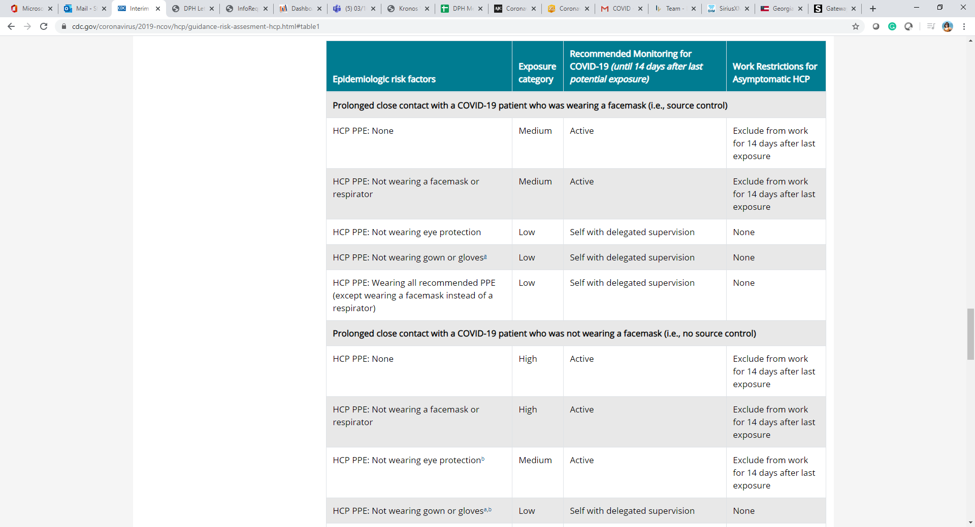
According to the CDC, if a healthcare provider comes in contact with a COVID positive or potential COVID positive patient and neither patient or HCP was wearing a mask, the recommendation is still 14-day self-quarantine. If this will leave the facility is short-staffed, then it can be allowed that the ASYMPTOMATIC HCP can return to work but must wear a mask. This has to be determined by the facility.

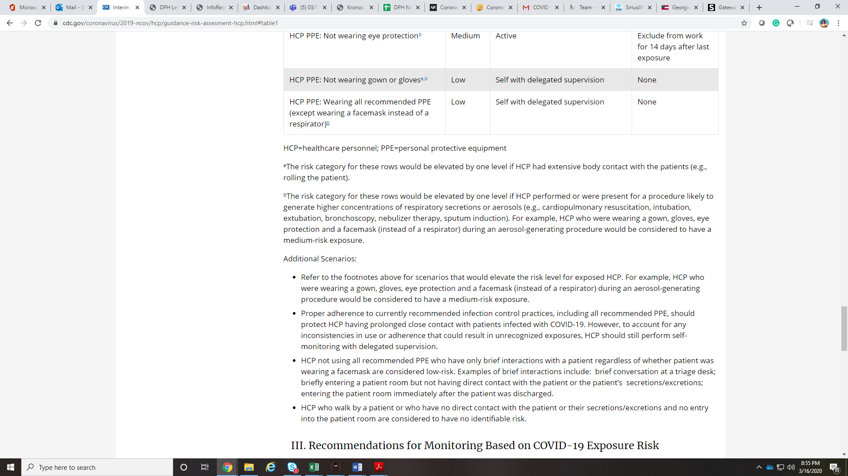

If a healthcare professional (HCP) calls inquiring about HCP EXPOSURE TO COVID, okay to discuss the above talking points.

If the caller’s questions cannot be answered and/or the HCPs want to also speak with MED EPI:
- 8 AM to 5 PM/ M-F, call DPH office at 404-657-2588.
- After 5 PM/ Weekends, call directly MED EPI on call. Refer to the MED EPI On-Call Schedule

Collect caller name, zip code, phone number. Document call as INFO CHART → PUBLIC HEALTH→ OTHER- PUBLIC HEALTH SITUATION sub-type.
Code SUBSTANCE: COVID-19 NONCONFIRMED
Type DESCRIPTION: COVID

Save, Validate, Close the case.
Do not email the case.

I am a healthcare provider and I want to get myself tested for COVID-19
- A medical colleague can take their NP sample and submit a PUI form to DPH using the online provider request (https://dph.georgia.gov/covid-19-provider-online-testing-request), or
- They can call or complete the registration form for a DPHSPOC site (https://dph.georgia.gov/covidtesting)

- They SHOULD NOT DELIVER THE SAMPLE THEMSELVES TO THE PUB HEALTH LAB THEMSELVES. Samples can only be delivered/accepted from couriers or others trained to transport such samples. This will likely be the fastest turn-around of DPH options, the SPOCs will take a few days.

If a healthcare professional (HCP) calls, okay to discuss the above talking points.

If the caller’s questions cannot be answered and/or the HCPs want to also speak with MED EPI:
- 8 AM to 5 PM/ M-F, call DPH office at 404-657-2588.
- After 5 PM/ Weekends, call directly MED EPI on call. Refer to the MED EPI On-Call Schedule

Collect caller name, zip code, phone number. Document call as INFO CHART → PUBLIC HEALTH→ OTHER- PUBLIC HEALTH SITUATION sub-type.
Code SUBSTANCE: COVID-19 NONCONFIRMED
Type DESCRIPTION: COVID

Save, Validate, Close the case.
Do not email the case.

PERSONAL PROTECTIVE EQUIPTMENT (PPE)
- Facemasks with eye protection are an acceptable alternative when the supply chain of N95 masks or respirators cannot meet the demand.
  - In settings where facemasks are not available, HCP might use homemade masks (e.g., bandana, scarf) for care of patients with COVID-19 as a last resort. However, homemade masks are not considered PPE, since their capability to protect HCP is unknown.
- Healthcare personnel entering the room should use standard precautions, contact precautions, airborne precautions, and use eye protection (e.g., goggles or a face shield)
  - Eye protection, gloves, and gowns remain in the recommendations, although if gowns are in limited supply, they may be reserved for aerosol-generating procedures.
- Patients should be asked to wear a surgical mask upon arrival and be evaluated in a private room with the door closed, ideally an airborne infection isolation room, if available.
More PPE info at https://www.cdc.gov/coronavirus/2019-ncov/hcp/ppe-strategy/

Collect caller name, zip code, phone number. Document call as INFO CHART → PUBLIC HEALTH→ OTHER- PUBLIC HEALTH SITUATION sub-type.
Code SUBSTANCE: COVID-19 NONCONFIRMED
Type DESCRIPTION: COVID

Save, Validate, Close the case.
Do not email the case.

If a healthcare professional (HCP) calls, okay to discuss the above talking points.

If the caller’s questions cannot be answered and/or the HCPs want to also speak with MED EPI:
- 8 AM to 5 PM/ M-F, call DPH office at 404-657-2588.
- After 5 PM/ Weekends, call directly MED EPI on call. Refer to the MED EPI On-Call Schedule

REQUESTING MORE PERSONAL PROTECTIVE EQUIPTMENT (PPE)

This can be done via one of two websites. Also suggest that the caller reach out to their district.
- Hospitals: https://ga.readyop.com/fs/4cMj/3b3f
- Other clinical providers (e.g. EMS, skilled nursing): https://ga.readyop.com/fs/4cMi/8d3e

**Please understand that our request to the federal stockpile is not able to be totally fulfilled and supplies are limited. Continue to try to source materials through your supply chains. For resource request follow up questions, please call 404-852-0250.

If a healthcare professional (HCP) calls, okay to discuss the above talking points.

If the caller’s questions cannot be answered and/or the HCPs want to also speak with MED EPI:
- 8 AM to 5 PM/ M-F, call DPH office at 404-657-2588.
- After 5 PM/ Weekends, call directly MED EPI on call. Refer to the MED EPI On-Call Schedule

Collect caller name, zip code, phone number. Document call as INFO CHART → PUBLIC HEALTH→ OTHER- PUBLIC HEALTH SITUATION sub-type.
Code SUBSTANCE: COVID-19 NONCONFIRMED
Type DESCRIPTION: COVID

Save, Validate, Close the case.
Do not email the case.

PPE FOR FIREMEN/ EMS/ LAW ENFORCEMENT
County EMAs and Health District EP personnel will be reaching out to EMS agencies and hospitals with a link where they can request PPE. Please follow the process outlined in the information that they receive. If they didn’t receive a link, have them call their county health department or local health district.

If a caller is inquiring about PPE for FIRST RESPONDERS, okay to discuss the above talking points.

Collect caller name, zip code, phone number. Document call as INFO CHART → PUBLIC HEALTH→ OTHER- PUBLIC HEALTH SITUATION sub-type.
Code SUBSTANCE: COVID-19 NONCONFIRMED
Type DESCRIPTION: COVID

Save, Validate, Close the case.
Do not email the case.

If the caller’s questions cannot be answered and/or the HCPs want to also speak with MED EPI:
- 8 AM to 5 PM/ M-F, call DPH office at 404-657-2588.
- After 5 PM/ Weekends, call directly MED EPI on call. Refer to the MED EPI On-Call Schedule

MEDICAL EXAMINER'S OFFICE/ CORONER’S OFFICE
If a healthcare provider (MD, RN, etc) calls to inquire about COVID testing for his patient.

Collect coroner’s name, zip code, phone number, EMAIL ADDRESS.

Talking Points:
If a medical examiner calls in wanting to test a corpse for COVID, please collect their email information and send them the following link https://dph.georgia.gov/covid-19-provider-online-testing-request GPHL can only test nasal swabs. They cannot test tissue.
If the caller is a coroner/ coroner’s office inquiring about testing a corpse for COVID and they DO NOT have the medical supplies for testing, collect the callers information (name, zip code, phone number) in a ToxSentry Info Chart and 8 AM to 5 PM/ M-F, call DPH office at 404-657-2588. If outside of these hours, email it to the DPH email address in ToxSentry.
Send them the following link: https://dph.georgia.gov/covid-19-provider-online-testing-request

Document call as INFO CHART → PUBLIC HEALTH→ OTHER PUBLIC HEALTH SITUATION sub-type
Code SUBSTANCE: COVID-19 NONCONFIRMED
Type DESCRIPTION: COVID

Save, Validate, Close the case.
Do not email the case.

HEALTHCARE PROFESSIONALS WHO RECENTLY TRAVELED

Q. I am a healthcare provider who has a patient scheduled to come into my facility who has traveled internationally, should I tell them not to come into the office? - updated 8/13/2020
- If an individual travels internationally, regardless of where they went or what they did, they should social distance, wear a mask, wash your hands, and monitor for symptoms.
- If they traveled from areas with high spread (https://www.cdc.gov/coronavirus/2019-ncov/travelers/map-and-travel-notices.html), then they should “stay home as much as possible for 14 days” which means quarantine.
https://www.cdc.gov/coronavirus/2019-ncov/travelers/after-travel-precautions.html
https://www.cdc.gov/coronavirus/2019-ncov/php/risk-assessment.html

HEALTHCARE PROFESSIONAL VOLUNTEER

Q. I am a licensed medical worker and would like to volunteer - updated 4/2/2020
- Licensed medical volunteers can offer their services by registering with the Emergency system for Advance Registration of Volunteer Health Professionals. This can be accessed through fema.gov

If a healthcare professional (HCP) calls, okay to discuss the above talking points.

Collect caller name, zip code, phone number. Document call as INFO CHART → PUBLIC HEALTH→ OTHER- PUBLIC HEALTH SITUATION sub-type.
Code SUBSTANCE: COVID-19 NONCONFIRMED
Type DESCRIPTION: COVID

Save, Validate, Close the case.
Do not email the case.

If the caller’s questions cannot be answered and/or the HCPs want to also speak with MED EPI:
- 8 AM to 5 PM/ M-F, call DPH office at 404-657-2588.
- After 5 PM/ Weekends, call directly MED EPI on call. Refer to the MED EPI On-Call Schedule

GENERAL PUBLIC INFORMATION

IN GENERAL, CALLS FROM THE LAY PUBLIC MANAGEMENT and DOCUMENTATION GUIDE
If a lay caller calls

Use the talking points on the following pages for ANY questions or concerns about COVID SAFETY CONCERNS/ EMPLOYEE and BUSINESS QUESTIONS/ TESTING/ VOLUNTEERING…
Refer to this manual to address their questions.
If sick, stay home, don’t go to school/work.
Tell caller to stay home until they have connected with their doctor/ clinic/ ED before going in.

Caller is instructed by DPH/CDC to report their daily temps because they have been identified as a close contact:
- Collect caller NAME, PHONE NUMBER, ZIP CODE, DOB
- Record their daily TEMPERATURE along with symptoms, if any.

- CHECK GOOGLE MTX FIRST FOR THE CALLER’S PROFILE – Still
Create a ToxSentry chart for our records

- IF GOOGLE MTX DOES NOT HAVE THE CALLER’S PROFILE, CREATE A TOXSENTRY CHART and follow instructions on page 51 to enroll the close contact into MTX. DO NOT ENROLL individuals that have tested positive in the last 90 days
Code SUBSTANCE: COVID-19 NONCONFIRMED
Type DESCRIPTION: COVID

Edit the SUBJECT line to provide summary of question
Check INCLUDE PDF.

Collect caller name, zip code, phone number. Document call as INFO CHART → PUBLIC HEALTH→ OTHER- PUBLIC HEALTH SITUATION sub-type.
Code SUBSTANCE: COVID-19 NONCONFIRMED
Type DESCRIPTION: COVID

Save, Validate, Close the case.
Do not email the case.

LANGUAGE LINE
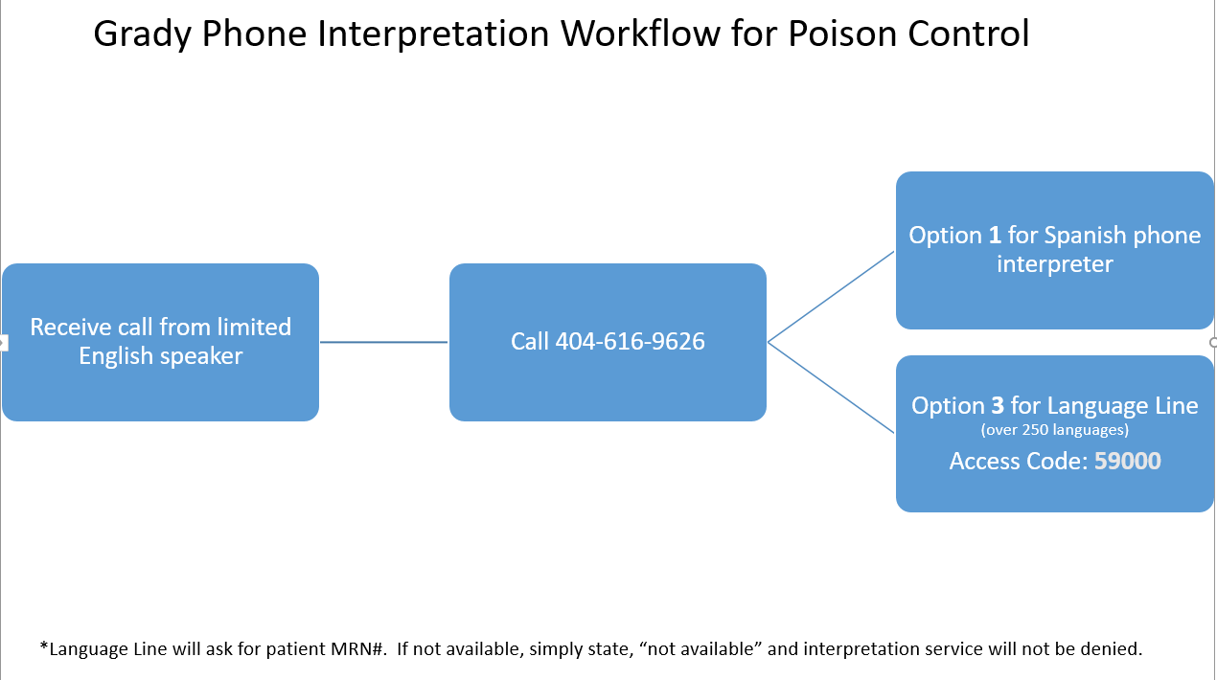

COVID-19 SAFETY CONCERNS

Q. I have a question or concern about the data on the Department of Public Health website. Who can I talk to? - updated 8/13/2020
You can also get the information from the caller about what they would like to see or what they are upset about not seeing and 8 AM to 5 PM/ M-F, call DPH office at 404-657-2588. If outside of these hours, email it to the DPH email address in ToxSentry.

On 5/27/2020 - DPH updated the website to include serology test result numbers, right now they only include the number of serology positives, not positives/negatives. That will be added in the future.

Q. I believe I may have been exposed / there is a positive COVID-19 case at my business etc - CDC Risk Assessment - updated 8/13/2020

When you receive a call from a member of the public with questions about possible exposures, contact with people who may have been exposed, or how their business should respond to potential exposures, refer them to the DPH website and links for business as well as the CDC risk assessment for community exposures:

  - https://dph.georgia.gov/COVID-19-businesses-and-employers
  - https://www.cdc.gov/coronavirus/2019-ncov/php/public-health-recommendations.html
If the caller is wanting to put in a complaint about further follow up needed at the workplace, please send to the district epidemiologist on call.
There is separate guidance for healthcare settings, which can be found here: https://www.cdc.gov/coronavirus/2019-ncov/hcp/guidance-risk-assesment-hcp.html. This will give them information they need to find out if their exposure falls into a high or medium risk category and what steps they should take.

If they need to google it, it is called the Interim U.S. Guidance for Risk Assessment and Public Health Management of Healthcare Personnel with Potential Exposure in a Healthcare Setting to Patients with Coronavirus Disease (COVID-19)

Q. I heard about the COVID-19 cases in my area/workplace/school system and I want to know if my family is at risk for exposure - updated 4/2/2020

We cannot release information on the school or work place of COVID-19 cases, but public health completes contact investigations and notifies all individuals who were a close contact to a confirmed cases and identified to be at risk and advises them for procedures of quarantine and symptom monitoring.

Q. Should I be concerned about community spread in Georgia? - updated 4/2/2020
Community spread is widespread in Georgia. It is important that you practice good hand hygiene and normal practices to prevent the spread of respiratory illness; additionally, it is important to adhere to current orders by the governor and local government and practice social distancing as much as possible. If you would like up-to-date information, you can visit our website at dph.georgia.gov

Q. What do I do if I am sick but I have not been identified as a close contact with a patient with COVID-19? - updated 8/13/2020
- If you are currently experiencing mild symptoms we recommend that you stay home and self isolate until at least 24 hours after symptom resolution without fever reducing medication, other symptoms have resolved and 10 days have passed since your onset of symptoms. Additionally, we recommend that Individuals be referred for testing at a DPH SPOC location. This allows us to know who is positive and whose close contacts need to be quarantined.

Q. I am a contact of asymptomatic people who were themselves exposed to COVID-19, should I be concerned? - updated 4/2/2020
- CDC does not recommend testing, symptom monitoring or special management for people exposed to asymptomatic people with potential exposures to SARS-CoV-2 (such as in a household), i.e., “contacts of contacts;” these people are not considered exposed to SARS-CoV-2. https://www.cdc.gov/coronavirus/2019-ncov/php/risk-assessment.html

Q. Should I be concerned if I hear that a friend has “coronavirus”? What is the difference between the 2019 novel coronavirus and regular seasonal coronavirus? - updated 4/2/2020
- Coronaviruses are a large family of viruses, some causing illness in people and others that circulate among animals, including camels, cats and bats. The recently emerged novel coronavirus is not the same as the seasonal coronavirus that causes illness commonly in people in the US. Common human coronaviruses, including types 229E, NL63, OC43, and HKU1, usually cause mild to moderate upper-respiratory tract illnesses, like the common cold. Most people get infected with these viruses at some point in their lives. These illnesses usually only last for a short period of time. Symptoms may include:
- runny nose
- headache
- cough
- sore throat
- fever
- a general feeling of being unwell
- Human coronaviruses can sometimes cause lower-respiratory tract illnesses, such as pneumonia or bronchitis. This is more common in people with cardiopulmonary disease, people with weakened immune systems, infants, and older adults.

Q. Do I need to be concerned if I see someone in public that is sick or wearing a mask? - updated 4/6/2020
CDC recommends the general public wear cloth face coverings in public settings– this does not necessarily mean that they are sick with novel coronavirus.
You should follow typical practices to prevent the spread of illness – frequently and thoroughly washing your hands with soap and warm water, avoiding touching your face to prevent spreading germs to mucus membranes of the nose, mouth, and eyes, and practicing social distancing as much as possible.
If you become ill, please continue infection control practices to prevent spread to others and visit your healthcare provider. You can find information on how to prevent spreading respiratory illness to others as well as information on flu in Georgia at the DPH website - https://dph.georgia.gov/flu-activity-georgia .
Q. I am planning a trip overseas, should I cancel it? - updated 4/2/2020
- CDC has released travel guidance for travelers that can be found at https://www.cdc.gov/coronavirus/2019-ncov/travelers/index.html .
- Currently, CDC recommends that travelers avoid all nonessential travel and many airlines are canceling service. CDC also recommends that all people defer travel on cruise ships, including river cruises, worldwide.
- There are also several travel restrictions being put in place by the federal government, please check online for these updated restrictions.
Q. Should I be wearing a mask? - updated 4/6/2020
CDC recommends wearing cloth face coverings in public settings and stay 6 feet apart from others.

Q. I was COVID-19 Positive and now I need to see my doctor. Do I need to test negative first?? - updated 6/6/2020
DPH and CDC does not recommend testing negative to be released from isolation. However, for non urgent medical visits, we would recommend waiting until the end of the isolation period. However, if urgent medical visit, please inform the provider prior to going in.

EMPLOYEE/ BUSINESS CONCERNS
Q. My company is interested in partnering for contact tracing. - updated 5/15/20

Thank the person for their call and kindly explain to them that DPH has already entered into a contract with another company. If individuals are looking to volunteer they can sign up through SERV Georgia: https://www.servga.gov/

Q. I lost my job as a result of COVID. - updated 5/15/20

Suggested resources: The governor’s office (constituent services), legal aid, OSHA. Refer them to call - 1-800-436-7442 (1-800-GEORGIA)

Q. How do I know if I can return to work? -- updated 8/13/2020
DPH recently updated guidance on return to work for health care and non-health care workers. These PDF’s can be found on https://dph.georgia.gov/ in the “DPH guidance (https://dph.georgia.gov/dph-guidance)” section.
DPH and CDC donot currently recommending the test-based strategy for return to work for non-health care workers. Individuals can test positive for up to 12 weeks, however they are no longer infectious after they complete their isolation period. It also requires TWO negative test results with samples taken least 24 hours apart. The test-based strategy is not fulfilled by a single test, nor should it be used for screening of all persons returning to work.

- DPH Guidance on discontinuing isolation can be found here: https://dph.georgia.gov/isolation-contact

- DPH guidance on return to work for health care providers: https://dph.georgia.gov/document/document/dph-return-work-guidance/download
- DPH guidance for businesses: https://dph.georgia.gov/document/document/dph-covid-19-return-work-guidance-after-covid-19-illness-or-exposure-persons-not/download

Q: Where can I find guidance on business re-opening? - Updated 5/14
The re-opening is being managed by the governor's office, not the department of public health. Please advise people to contact the governor's hotline (844-442-2681) with specific questions and also review the guidance on the governor's website (gov.georgia.gov).

A few links to get people started are below:
- Governor Executive Orders: Providing additional guidance for reviving a healthy Georgia in response to COVID-19 (5/12)
  - restaurants and dining services
  - industry, commerce, organizations and nonprofits
  - healthcare
  - education and children
  - driver's services
- Governor Press Releases: https://gov.georgia.gov/press-releases
  - This has press releases which discuss new guidance the governor's office is releasing, such as Cosmetology & Barbers.
- OSHA guidance on preparing workplaces for COVID-19: https://www.osha.gov/Publications/OSHA3990.pdf
- Georgia Department of Economic Development, Guidelines for Businesses: https://www.georgia.org/covid19bizguide
- Georgia Restaurants: www.garestaurants
**The governor's 844 hotline is different than the 866 hotline that you are answering.

Q. I want to report a person or business based on the Governor’s Order. - updated 4/16/2020
- Go to www.gov.georgia.gov
- Click on “Contact Us”
- Click on “Constituent Services”, which will take them to a form to fill out.
- They should include the following information in their report:
  - Business Name
  - Address
  - Telephone Number
  - Specific details for the complaint

Q. I heard my schools are closed, is this true? - updated 4/2/2020

Some school systems have sent out an email concerning school closures and face-2-face learning. You should check with your individual school or school system to determine if your school is closed and for how long.

Q. Am I considered to be an essential worker or someone who needs to stay home? - updated 4/2/2020
We recommend checking your local government website directly for orders that may be more stringent or have more information (ex. Mayor Keisha Lance-Bottoms issued a stay-at-home order) in addition to the information in the Governor’s Exective Order.
You can find the governor’s decree on the governor’s website under “Executive Action” and then “Executive Orders” which has more information about the specifics required statewide including closures of businesses and requirements on numbers of persons allowed in a business and distance required between people (6 ft). You can also watch his press conference on the DPH website.

Q. Is my office open, do I have to go to work? - updated 4/2/2020

- You should call your office to find out if they are open and if they expect you to be there.
- You should review the governor’s decree and any local ordinances that have details on essential work functions, this may vary across the state as local requirements may be imposed in addition to the governor’s order.
- If you do not feel that you should be going to work, you should let your employer know, provide them with the information you have which shows that you are not on the essential work function list and work out an option for teleworking if possible. We are not able to assess essential work function over the phone.
- If you feel your company is operating against the governor’s order, we can take that information (Business name, address info if you have it, any details possible).

Q. Can I get a letter from DPH stating I need to quarantine or self-isolate to share with my employer? - updated 4/7/2020
Individual letters will not be issued to employees by DPH concerning a person's ability to work. https://dph.georgia.gov/COVID-19-businesses-and-employers

Q. I would like someone to come to my business/school/church to present on Coronavirus? - updated 4/2/2020
- At this time we are unable accommodate individual presentations. We currently have information available on our website: www.dph.georgia.gov.
- Businesses that want to sell medical supplies or equipment to the federal government please email specifics to covidsupplies@fema.dhs.gov

Q. What about Corrections facilities? - updated 4/2/2020
- When receiving questions about corrections facility you can refer to the CDC guidelines, these can be accessed by entering “CDC COVID-19 corrections guidance” into Google.

Q. I would like my business/school/church to become a Coronavirus testing site. How can I go about setting up this testing site? - updated 6/22/2020
- Direct the caller to the COVID-19 TESTING HOTLINE for their county of residence. See Page 35 in this manual for the DISTRICT HOTLINES.
- i.e. A church located in Hall County wants to become a Covid-19 testing site, direct them to call their district’s COVID-19 HOTLINE (Hall County/Dist 2-Gainesville) for further information and instructions.

Q: I operate a daycare/ work in a daycare… a staff member and/or a child tested positive for COVID-19. What do I do now? Updated 7/7/2020
CALL YOUR LOCAL HEALTH DEPARTMENT ASAP TO COORDINATE CLOSURES AND INVESTIGATIONS
Regarding closures: The daycare does not need to close the entire facility when a COVID-19 case is identified. However, a particular classroom or area may need to be temporarily closed for 14 days. In collaboration with local public health, daycares should identify individuals who were exposed to the case(s) and make a determination to close certain classrooms/areas based on exposure history. Please see the below recommendations for guidance

Childcare centers should collaborate with public health to identify ALL close contacts using the below criteria:
• Anyone who was in the same classroom as the case should be considered a close contact and exposed
• Consider the facility’s drop-off and pick-up procedures, specifically whether children are placed in the same classroom during drop-off or pick-up before being dispersed to individual classrooms. Anyone who may have been in the same room during drop-off or pick-up should be considered a close contact and exposed
• Consider whether teachers or staff switch classes and may have been exposed
• Close contacts must be excluded from the childcare setting and self-quarantine for at least 14 days after exposure. The classroom setting where the case was based may need to close temporarily as students and teachers quarantine
• Additional areas of the childcare facility visited by the case may also need to be closed temporarily for cleaning and disinfection
• Notify student’s parents, staff, and teachers of any positive cases while maintaining confidentiality

In regards to the 2-5 days vs. 14 days, CDC recommends closing for 2-5 days while determining a long term course which may include closure for 14 days. The 2-5 days allows public health and the facility to perform a thorough investigation and determine who was exposed to the case. This also gives the facility time to clean and disinfect properly. Upon the conclusion of the investigation, those who are determined to have close, prolonged contact will be required to quarantine for 14 days, while others will be allowed to come back to the facility

TESTING
Q. I want to be tested for Coronavirus, where can I be tested? - updated 5/28/2020

CALL YOUR PRIVATE PHYSICIAN or LOCAL URGENT CARE. They may be conducting testing at this time. Other options:…

SPOC: Visit https://dph.georgia.gov/covidtesting schedule an appointment to be tested at a DPH SPOC site.

This will still require for you to travel to the SPOC site to be tested. You should NOT show up at a site without an appointment. Additionally, it’s important to know that results from the SPOCs may take some time to come back.

**Please ask the caller for their county of residence and refer to the list below for the phone number to share with them**

If you are unable to travel to a SPOC or a local urgent care or doctors office and are mildly ill, we recommend that you self isolate at home until 24 hour after fever resolution with other symptoms improving or 10 days after symptom onset, whichever is longer. If your symptoms worsen and you feel you need immediate, emergency medical care, you should call 911.
https://dph.georgia.gov/covidtesting
Direct Patient lines are open:
8:30am to 5:00pm Monday through Friday
8:30am – Noon on Saturdays.

DPH - HEALTH DISTRICT | COVID-19 TESTING LINE | COUNTIES SERVED
DISTRICT 1-1 / ROME / Northwest Georgia Health District  www.nwgapublichealth.org | 706-802-5329 | Counties served:  Bartow, Catoosa, Chattooga, Dade, Floyd, Gordon, Haralson, Paulding, Polk, Walker
DISTRICT 1-2 / DALTON / North Georgia Health District  www.nghd.org | 1-888-881-1474 Call center | Counties served:  Cherokee, Fannin, Gilmer, Murray, Pickens, Whitfield
DISTRICT 2 / GAINESVILLE / North Health District  www.phdistrict2.org | District Office: 770-535-5743  Banks County HD: 706-677-2296  Dawson County: 706-265-2611  Forsyth County: 770-781-6900  Franklin County: 706-384-5575  Habersham County HD: 706-778-7156  Hall County HD:770-531-5600  Hart County HD: 706-376-5117  Lumpkin County HD: 706-867-2727  Rabun County HD:706-212-0289  Stephens County HD: 706-282-4507  Towns County HD: 706-896-2265  Union County HD: 706-745-6292  White County HD: 706-865-2191 | Counties served:  Banks, Dawson, Forsyth, Franklin, Habersham, Hall, Hart, Lumpkin, Rabun, Stephens, Towns, Union, White
DISTRICT 3-1 / MARIETTA / Cobb/Douglas Health District  www.cobbanddouglaspublichealth.com | 770-514-2300 | Counties served:  Cobb, Douglas
DISTRICT 3-2 /ATLANTA / Fulton County Board of Health  www.fultoncountygahealth.org | 404-613-8150. | Counties served:  Fulton
DISTRICT 3-3 / JONESBORO / Clayton County Health District  www.claytoncountypublichealth.org | 678-479-2223 | Counties served:  Clayton
DISTRICT 3-4 / LAWRENCEVILLE / East Metro Health District  www.gnrhealth.com | 770-513-5631 | Counties served:  Gwinnett, Newton, Rockdale
DISTRICT 3-5 / DECATUR / DeKalb Health District  www.dekalbhealth.net | 404-294-3700 Option 1 | Counties served:  DeKalb
DISTRICT 4 / LAGRANGE / District 4 Health District  www.district4health.org | 1-800-847-4262 | Counties served:  Butts, Carroll, Coweta, Fayette, Heard, Henry, Lamar, Meriwether, Pike, Spalding, Troup, Upson
DISTRICT 5-1 / DUBLIN / South Central Health District  www.southcentralhealth.info | 478-275-6570 | Counties served:  Bleckley, Dodge, Johnson, Laurens, Montgomery, Pulaski, Telfair, Treutlen, Wheeler, Wilcox
DISTRICT 5-2 / MACON / North Central Health District  www.northcentralhealthdistrict.org | 1-844-987-0099 | Counties served:  Baldwin, Bibb, Crawford, Hancock, cherokHouston, Jasper, Jones, Monroe, Peach, Putnam, Twiggs, Washington, Wilkinson
DISTRICT 6 / AUGUSTA / East Central Health District  www.ecphd.com | 706-721-5800 (ask for testing). | Counties served:  Burke, Columbia, Emanuel, Glascock, Jefferson, Jenkins, Lincoln, McDuffie, Richmond, Screven, Taliaferro, Warren, Wilkes
DISTRICT 7 / COLUMBUS / West Central Health District  www.westcentralhealthdistrict.com | 706-321-6300 | Counties served:  Chattahoochee, Clay, Crisp, Dooly, Harris, Macon, Muscogee, Marion, Quitman, Randolph, Schley, Stewart, Sumter, Talbot, Taylor, Webster
DISTRICT 8-1 / VALDOSTA / South Health District  www.southhealthdistrict.com | Ben Hill County: 229-426-5288  Berrien County: 229-686-5411  Brooks County: 229-263-7585  Cook County: 229-896-3030  Echols County: 229-559-5103  Irwin County: 229-238-9540  Lanier County: 229-482-3294  Lowndes County: 229-333-5257  Tift County: 229-386-8373  Turner County: 229-238-9595 | Counties served:  Ben Hill, Berrien, Brooks, Cook, Echols, Irwin, Lanier, Lowndes, Tift, Turner
DISTRICT 8-2 / ALBANY / Southwest Health District  www.southwestgeorgiapublichealth.org | 229-352-6567 | Counties served: Baker, Calhoun, Colquitt, Dougherty, Decatur, Early, Grady, Lee, Miller, Mitchell, Seminole, Terrell, Thomas, Worth
DISTRICT 9-1 / SAVANNAH/ BRUNSWICK / Coastal Health District  www.gachd.org | Bryan County: 912-756-2611 (Richmond Hill)  Bryan County: 912-653-4331 (Pembroke)  Camden County: 912-882-8515 ext. 215  Chatham County: 912-356-2441  Effingham County: 912-754-6484  Glynn County: 912-264-3961 - Opt. 5  Liberty County: 912-876-2173  Long County: 912-545-2107  McIntosh County: 912-832-5473 | Counties served:  Bryan, Camden, Chatham, Effingham, Glynn, Liberty, Long, McIntosh
DISTRICT 9-2 / WAYCROSS / Southeast Health District  www.sehdph.org | 1-855-473-4374  1-855-4(SEHDPH) | Counties served:  Appling, Atkinson, Bacon, Brantley, Bulloch, Candler, Charlton, Clinch, Coffee, Evans, Jeff Davis, Pierce, Tattnall, Toombs, Ware, Wayne
DISTRICT 10 / ATHENS / Northeast Health District  www.publichealthathens.com | 706-340-0996. | Counties served:  Barrow, Clarke, Elbert, Greene, Jackson, Madison, Morgan, Oconee, Oglethorpe, Walton

Q. I was tested _X_ days ago. How can I receive my results? -- updated 5/21/2020
The turnaround time for tests varies significantly by the lab conducting the test. We recommend you call the facility where you were tested to obtain results.
- DPH lab is 2-3 days, but could be longer if resources are being saturated. Most labs are conducting tests over the weekend.
- Commercial testing turnaround is 4-7 days.
- DPH lab turn-around-time may be increasing due to supply and demand.

If the person was tested at a District SPOC (mobile testing drive through):
These sites are managed by the districts, and the district will contact them with their results. Turnaround time is approximately 5-7 days. These tests are run at commercial labs and we do not have control over turn around times. If it has been longer than 7 days, advise them to contact their district directly.

In the following situations, please get the person’s name (first and last with spelling), phone number, PUI number, and location where they were tested:

- They already tried to contact their district and were referred back to DPH
- It has been 2 or more weeks since they were tested
- They were tested by the national guard and aren’t sure how to get their results.

Please then post a message in the chat letting an epi support know you have this information (please do not post the caller’s info in the chat), and we will reach out to you to get it to follow up.

- If they were tested at a Fulton County Board of Health site, they can now log onto https://patient.labcorp.com/ to check their results online.

If the person was tested at Mercedes-Benz stadium (in Atlanta) via CORE, they should be receiving their results from this location. At this time, this location is not affiliated with the department of public health so we cannot provide test results. The lab working with this team is called Curative Inc – if needed, callers can try to reach this lab directly (curativeinc.com).

Q: Where can I get antibody testing? -- updated 5/4/2020
CALL YOUR PRIVATE DOCTOR OR LOCAL URGENT CARE for antibody testing locations
Callers interested in antibody testing should contact their primary care providers for more information. DPH is not currently performing antibody testing and doesn’t maintain a list of who performs antibody testing. If a caller has questions about antibody testing, you can refer them to CDC’s website: https://www.cdc.gov/coronavirus/2019-ncov/lab/serology-testing.html.

Key points:
- We do not know if antibodies will provide someone with immunity from future infection.
- Antibody tests should not be used as the sole basis to diagnose someone with active infection. It typically takes 1-3 weeks after someone has been infected to make antibodies; some people may take longer.

Q. I heard CDC was doing a study in DeKalb and Fulton. Can I be included? - updated 5/4/2020
Sample collection has been completed. No longer taking samples at this time. Thank the caller for their interest.

Q. I participated in the DeKalb/Fulton sero-survey, when will I get my results? Updated 5/18/2020

Approval to report results back to patients has been granted. Results will be reported back to participants in a letter from DPH in the mail, if they elected to receive results at the time their sample was taken. This may take a few weeks to months to hear back about.

VOLUNTEER

Q. Where can I apply or volunteer for contact tracing – updated 5/6/2020

Currently positions are posted on the DPH website for paid student internships and paid positions (https://www.governmentjobs.com/careers/georgiadph). If individuals are looking to volunteer they can sign up through SERV Georgia:https://www.servga.gov/

Q. Where can I donate blood or plasma? - updated 5/6/2020

Please contact Atlanta Blood Services for more information: www.atlantabloodservices.com.

Q. How can I donate or sell medical supplies or equipment? - updated 4/2/2020
- Businesses with medical supplies or equipment to donate are asked to go to www.fema.gov and provide the offer through the online medical supplies and equipment form. The direct link is https://www.fema.gov/covid19offers

Contact Tracing/ Google MTX Platform Information/ 888-357-0169
The Google MTX Platform will be used in Georgia for contact tracing. These close contacts will be instructed to call 888-357-0169 if they have questions or if they do not want to text their symptom checks and would rather call in.

Talking Points for the PH Staffers, As Needed…
Provide the following information to the close contacts:
It is very important for your own safety and for the safety of others that you monitor your health for 14 days from your last possible exposure to COVID-19, and that you remain at home, avoid congregate settings and public activities, and practice social distancing. You are required to cooperate fully with all state and federal public health authorities, including the Georgia Department of Public Health, and to follow the measures outlined below. The Georgia Administrative Order for Public Health Control Measures can be found here: https://dph.georgia.gov/document/document/secondamendedaoiq41201pdf/download

Specifically, you agree to:
If you are not sick, you agree to monitor your health for fever, cough and shortness of breath during the 14 days after the last day you were in close contact with the sick person with COVID-19.
- Check your temperature twice a day and watch for symptoms.
- Quarantine yourself at home except in case of emergency or to be tested for COVID-19.
- If you are a health care provider, emergency medical services worker, first responder, or other critical infrastructure worker, you may continue to work, in consultation with your workplace occupational health program and if necessary to ensure adequate staffing, if you have no symptoms, wear a mask while on duty, and remain at home at all other times.
- If possible, stay away from other people living in your home, especially those who are at high risk for getting very sick from COVID-19: https://www.cdc.gov/coronavirus/2019-ncov/need-extra-precautions/index.html
- When you are contacted by the public health, enroll in active monitoring. Through active monitoring, you will report your temperature and any symptoms to the Georgia Department of Public Health each day, either by responding to a text message or calling 1-888-357-0169 if you are unable to text.
- If you have not been contacted by public health, but feel you have been in contact with COVID-19, please call 1-888-357-0169.
* A person who has clinically recovered from COVID-19 and then is identified as a contact of a new case within 3 months of symptom onset or first positive test of their most recent illness does not need to be quarantined as discussed in this document. However, if a person is identified as a contact of a new case 3 months or more after symptom onset or first positive test, they should follow quarantine recommendations for contacts.

COVID-19 Testing. You should obtain a test for COVID-19 at least once during your quarantine. If you have no symptoms, the test should take place on the 10th day of quarantine. You should obtain a test earlier in your quarantine if you experience any of the following symptoms:
- Fever (measured temperature above 100.4 degrees Fahrenheit, or you feel feverish)
- Chills
- Cough
- Shortness of breath or difficulty breathing
- Fatigue
- Muscle or body aches
- Headache
- New loss of taste or smell
- Sore throat
- Congestion or runny nose
- Nausea or vomiting
- Diarrhea

Call your local health department to schedule testing. You can find contact information for your health department here: https://dph.georgia.gov/covidtesting. Please note that even if your test results are negative, you still must remain in quarantine for the entire 14 days. If you develop symptoms of COVID-19 at any point during your quarantine period, please also follow the guidance below “What should I do if I am a close contact to someone with COVID-19 and get sick?”.

If you seek a COVID-19 test during your quarantine, and you have not received results by day 14 of your quarantine, it is recommended that you do not return to work or school until those results are available. If your results are still pending after your 14-day quarantine is complete, and you decide to return to school or work, we recommend that you take extra care with prevention measures to avoid exposure to others in case your test result comes back as positive.
If you receive a positive COVID-19 test regardless of your symptom status, you must follow DPH isolation guidelines https://dph.georgia.gov/isolation-contact.
What is contact tracing?
Contact tracing is part of the process of supporting patients with suspected or confirmed infection. In contact tracing, Georgia department of public health staff work with a patient to help them recall everyone with whom they have had close contact during the timeframe while they may have been infectious. DPH staff will warn those exposed individuals (contacts) of their potential exposure.
Why doesn’t DPH tell the contact who or where they were exposed?
To protect patient privacy, contacts are only informed that they may have been exposed to a patient with the infection. They are not told the identity of the patient who may have exposed them.

How may I have been exposed?
You generally need to be in close contact with a sick person to get infected. Close contact includes:
- Living in the same household as a sick person with COVID-19;
- Caring for a sick person with COVID-19;
- Being within 6 feet of a sick person with COVID-19 for a total of 15 minutes*; OR,
- Being in direct contact with secretions from a sick person with COVID-19 (e.g., being coughed on, kissing, sharing utensils, etc.).
*Recommendations may vary on the length of time of exposure, but a total of 15 minutes of close exposure can be used as an operational definition. Data are insufficient to precisely define the duration or length of time for prolonged exposure. Additionally there is little data to determine the effect of multiple short term exposures (when the cumulative exposure equals or exceeds 15 minutes). Brief interactions are less likely to result in transmission; however, the type of interaction (e.g., did the infected person cough directly in another person's face or did the infected person engage in high-exertion exercise with others) remain important. Individuals who are unable to maintain social distance from others throughout the day (e.g., individuals have multiple exposures to a case and either are unable to calculate total time exposed or exposure equal or exceed 15 minutes in total) will be considered a close contact. If a person clearly meets definitions as a “close contact”, that person should follow quarantine guidance prior to public health assessment. If there are questions Public Health will perform a risk assessment to determine who is considered a close contact if the duration or type of contact is in question.
What should I do if I am a close contact to someone with COVID-19 and get sick?
If you develop symptoms of COVID-19 (even if your symptoms are very mild), you must stay at home and away from other people.
- Call 911 immediately if you believe you are experiencing a medical emergency. You must inform 911 that you may be sick with COVID-19 and wear a face covering.
- If it is not an emergency, but you are sick and require medical care, please contact your primary care doctor, an urgent care clinic, or your local federally qualified healthcare center.
- If you are mildly ill and do not require medical care, you can schedule testing by calling your local health department. You can find contact information for your health department here: https://dph.georgia.gov/covidtesting
- In order to prevent spreading COVID-19 it is critical that you follow the isolation instructions found here: https://dph.georgia.gov/isolation-contact
- The information provided here is not intended or implied to be a substitute for professional medical advice, diagnosis or treatment.
What should I do if I am a close contact and I want to enroll into the monitoring system but I have not been contacted by Public Health yet?
- Please visit https://dph.georgia.gov/contact for more information on quarantine and a link to enroll into the monitoring system.

GOOGLE MTX INSTRUCTIONS

If a contact calls and indicates they are unable to use the text-based system to do their active monitoring:

- Sign into Google MTX system: Log in with username and password:
  - Log into the MTX platform here: https://gdph-erm-274415.appspot.com/login.
  - The main dashboard will appear:
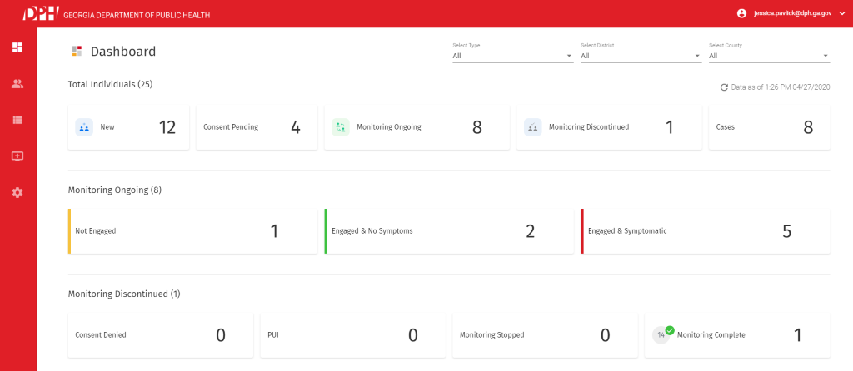

- On the left-hand side please select the picture that looks like a person:


- You can then search for the caller’s name or phone number in the search box. Set the list as ALL. Verify the callers DOB, Address, Phone number to ensure you are entering the correct profile.
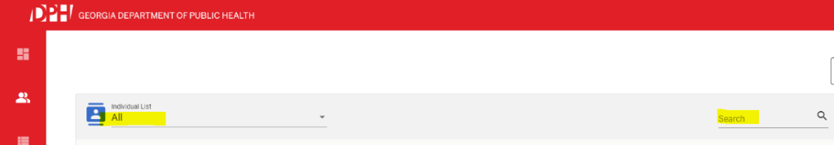

- Click on the patient monitoring ID to enter that patient’s file:

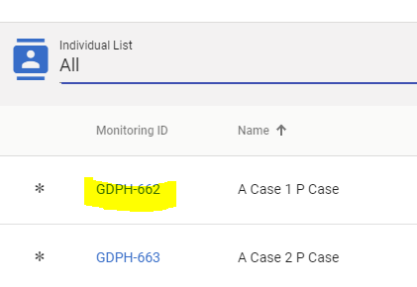

- Then click on the Add Symptom button.

  - You will be brought to a new screen. You can select Yes or No to symptoms.
    - If Yes to symptoms, add symptoms and click submit. *Note- If this phone number is used for more than one person, then they will all show up on this screen and all symptoms have to be put in at one time. Make sure you input symptom check under the correct individual!
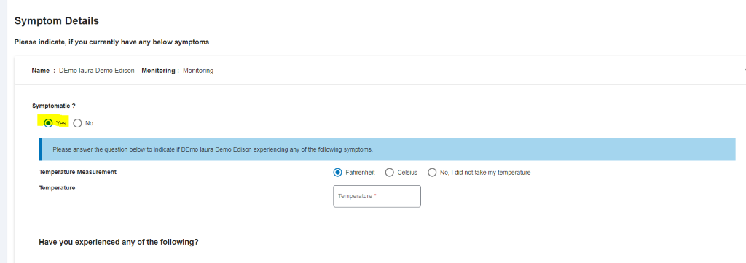

    - If No symptoms, click no and submit.
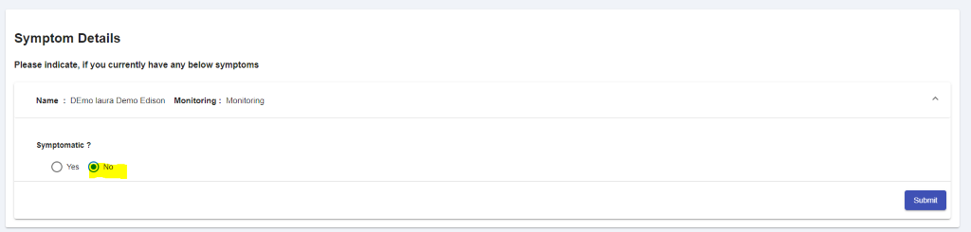

    - If there is more than one person associated with the number, it will appear this way. You will have to put in all symptom checks and then hit submit. You cannot only do one.
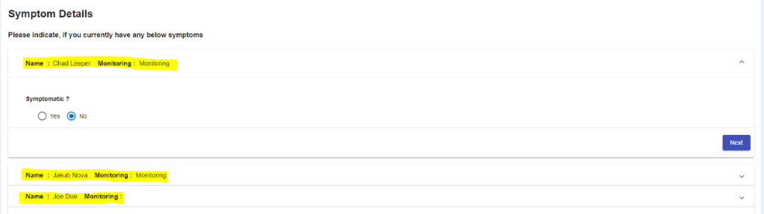

- Lastly, once you hit submit, please add a note in the Note field that you completed a symptom check for that person. “Symptom check complete, 5/9/2020” for example.
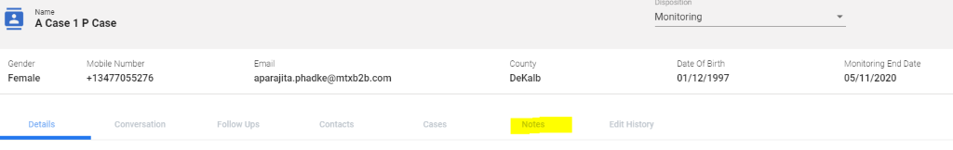

- If you find a discrepancy within the profile (i.e. birth year should be 1977, however 1978 is entered), you can update this information, however, you must ensure that all the other information entered matches with the person you are speaking with.

- For GOOGLE MTX password reset
https://forms.office.com/Pages/ResponsePage.aspx?id=DaEtURsHlEuKvJ7EBE0VFgISBnDoNTFGuoVeHyy5tnhUQUxLUU1SQ0M4SjRNNVZaVThLMzBSM1VNMi4u

CONTACT TRACING DOCUMENTATION

Every Caller Contract Tracing Call requires a TS Info Chart to be Created with Minimal Input:
- Please collect the caller’s NAME, DATE OF BIRTH, ZIP CODE, and PHONE NUMBER.
- Create a ToxSentry Info Chart--- > Call Type: Public Health -→ Sub-Type: Other Public Health
- Please collect the caller’s NAME, DATE OF BIRTH, ZIP CODE, and PHONE NUMBER.
- Description: COVID
- Substance Code: COVID-19 Non-Confirmed
- Type in the comments: “Contact Tracing”
Close the Chart… do not send to DPH.
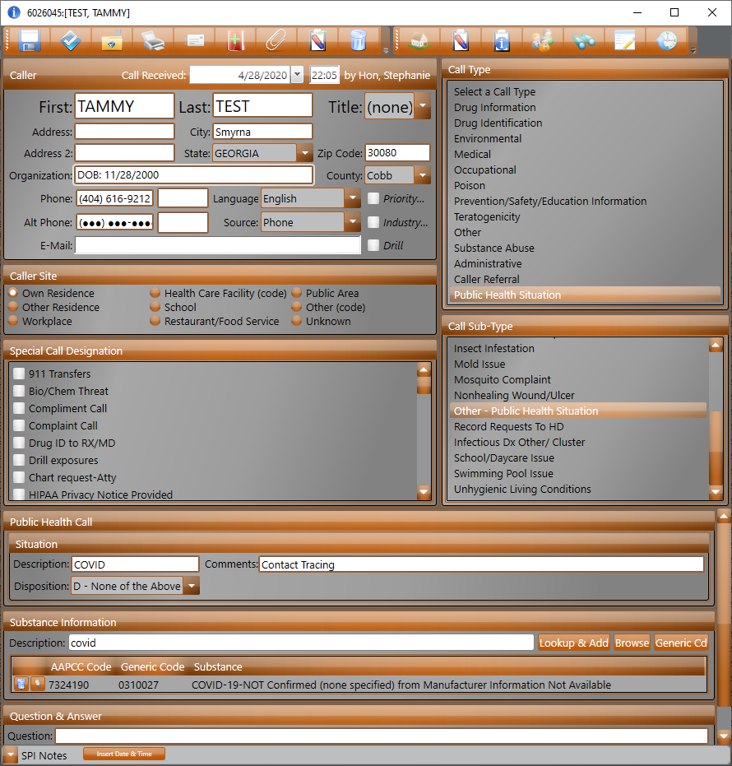

If a contact calls regarding contract tracing and they are not in the Google MTX Platform:

Use the guidelines if a person calls and wants to be enrolled in monitoring, but they have not been contacted by public health.

*If a person tested positive for COVID-19 in the last 90 days, they do not need to be monitored or entered into the system.*
Enrolling Close Contacts into Monitoring
GPC Hotline

Use the guidelines if a person calls and wants to be enrolled in monitoring, but they have not been contacted by public health. You can manually add them or direct them to https://dph.georgia.gov/contact where they can enroll themselves through the link at the top of the page (https://intake-app-dot-gdph-erm-274415.appspot.com/).

*If a person tested positive for COVID-19 in the last 90 days, they do not need to be monitored or entered into the system.

- Once you are sure the person is not already in MTX (searched by name and phone number), then click “Add Individual” at the top right hand corner of the search page.
- Enter all highlighted information listed below:
  - Name
  - Date of Birth
  - Primary phone number (If they only have a landline, this would go here)
  - Race
  - Ethnicity
  - Gender
  - Pregnancy information if female
  - Language Preference
  - Employer/school name
  - Have you been tested for COVID-19 during this current illness? (If they have tested positive in the last three months, they do not need to be enrolled in monitoring. If they have tested negative, they still have to complete their 14 days of quarantine.)
    - If they have been tested, add the date of test and the result.
  - Have you been in contact with someone who is confirmed or suspected to have COVID-19?
  - Are you a Healthcare worker?
    - Healthcare workers can continue to work if exposed and their facility has no other option to replace them, but must follow the guidelines here https://www.cdc.gov/coronavirus/2019-ncov/community/critical-workers/implementing-safety-practices.html
  - Are you an Essential employee (heathcare worker, nursing home staff, first responder, grocery store, etc.)
    - Essential workers are allowed to continue working if they have been exposed and their facility has no other option to replace them, but must follow the guidelines here: https://www.cdc.gov/coronavirus/2019-ncov/community/critical-workers/implementing-safety-practices.html
  - Do you live or work in a congregate setting (e.g. dormitory, long term care facility, etc.)?
    - If a person says yes, please notify your team leads.
  - Smoking status
  - Address (County is required)
  - Guardian Information (if a minor)
  - Pre-existing conditions

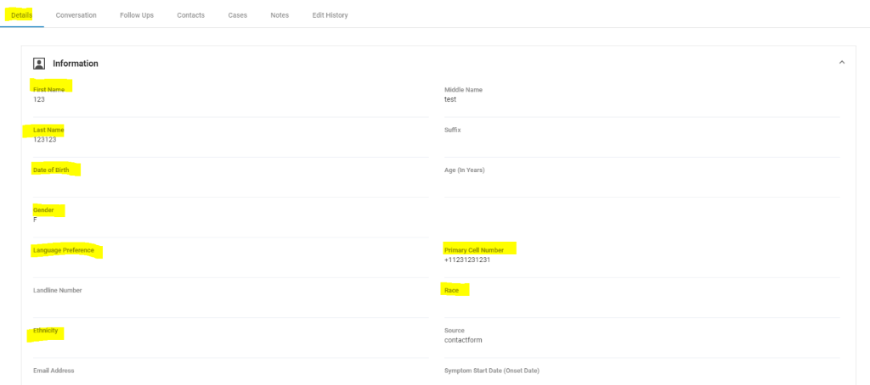
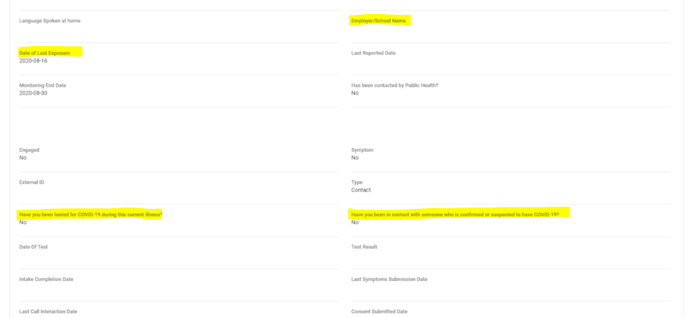
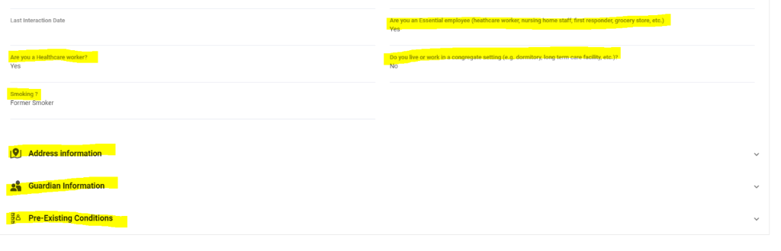
- Once all information is input into the system, hit save. You will be brought back to the search page. Find the file you just made.
- Next say “It is very important for you to monitor your temperature and symptoms so that you can be taken care of and treated quickly if you get sick and avoid making other people sick. Based on what is known for other coronavirus infections, 14 days is the longest time between when you were last exposed to a coronavirus and when symptoms begin. Based on your possible exposure date, your monitoring period will end on __(date of end)__. Take your temperature each morning and before bed each night and record your temperature and any symptoms you are having (If they do not have a thermometer, they can just report if they feel feverish). Report your symptoms daily. You will do this every day until ­­­­­­­­­­­­­___(date of end). We have several ways that you can report your temperatures and symptoms. Are you able to send and receive text messages?
  - If the individual wants to report by SMS
    - Go to conversation tab and click the highlighted button and then click Request Consent. The box should disappear and a text message automatically sent. It will appear in the conversation box.
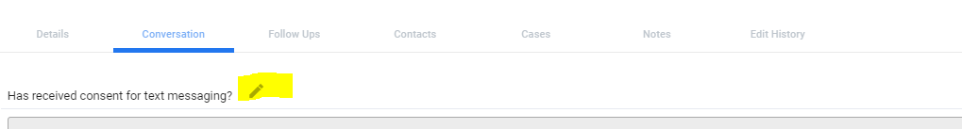
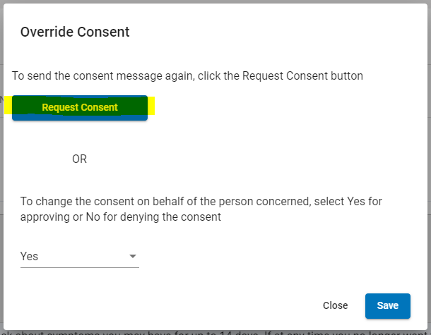
    - Say “You will receive a text from the Georgia Department of Public Health that includes our privacy information and that asks for your consent to receive text messages from DPH to monitor your health. Please reply “Yes” to provide your consent. You will then get two texts that confirms your consent and says that you will receive texts daily asking about any symptoms you have.”
        - Actual text language: “DPH: The Georgia Department of Public Health thanks you for enrolling in text-based monitoring. Please review DPH’s privacy practices at https://dph.georgia.gov/notice-privacy-policies and https://dph.georgia.gov/dph-privacy-policy-notice-disclaimers. Do you acknowledge receipt of DPH’s privacy practices and agree to receive and respond to daily text messages from DPH regarding your health? Carrier charges may apply. By replying “Yes,” you accept the risks of receiving text messages containing health information, including the risk that another person could see and read the contents. Your choice will NOT affect your eligibility for, or participation in, any DPH program. Please reply "Yes" or "No"”
        - Once they say yes, they will get two texts that say:
          - Message 1 : “DPH: Thank you for helping DPH prevent and control the spread of COVID-19. If you are a contact and in quarantine, we will be texting you daily to ask about any symptoms you may develop. More information on quarantine can be found at https://dph.georgia.gov/contact or call 1-888-357-0169. If you tested positive, you will have the opportunity to report additional contacts. More information for positive individuals may be found at https://dph.georgia.gov/isolation-contact."
          - Message 2 : “DPH: A new record has been added to this number If you are a contact and in quarantine, we will be texting you daily to ask about any symptoms you may develop. More information on quarantine can be found at https://dph.georgia.gov/contact or call 1-888-357-0169. If you tested positive, you will have the opportunity to report additional contacts. More information for positive individuals may be found at https://dph.georgia.gov/isolation-contact.”
        - Confirm that the individual has responded to the consent text message prior to ending the call by looking in the conversation tab.
        - Change the contacts disposition to “Monitoring” and status to “Report by SMS”.
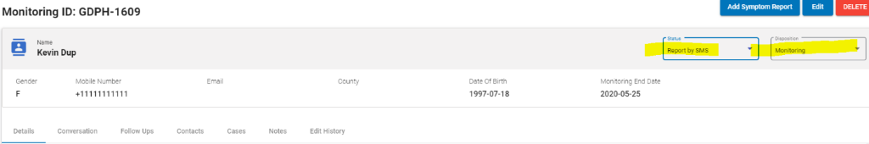
  - If the individual wants to report by phone:
    - Say “You will need to call the Georgia Contact Tracing Hotline daily at 1-888-357-0169 to report your symptoms. Please listen to the prompts and select the number that corresponds with symptom reporting. A representative will then ask you about any symptoms and input that information into the monitoring system for you.”
    - Go to conversation tab and click the highlighted button and then change the consent on behalf of the person by selecting YES and then click SAVE.
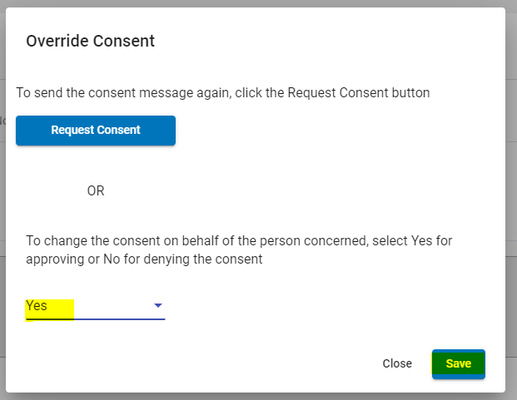
    - Change the contact disposition to “Manual” and the status to “Report by Phone”.
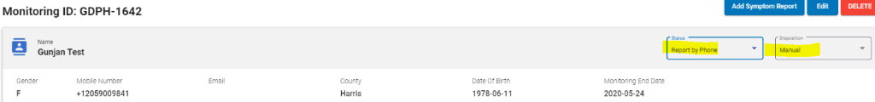
- Finally, input their first symptom check and make a note that this person was entered by GPC and as much information about the persons exposure as you can. Information on how to do these two steps can be seen in the directions on how to input a symptom check.
- End the call with the guidance below:

It is very important we receive your symptom report daily. If you are enrolled in the text messaging system, you will receive a text message reminder each day.
COVID-19 testing is recommended for all close contacts 10 days after their exposure. If you develop symptoms before day 10, you can be tested earlier. Please note that even if your test results are negative, you still must remain in quarantine for the entire 14 days. To schedule testing, please see the GDPH website.

If you do develop a fever or symptoms and need emergency medical care, please notify the facility that you may have COVID-19 ahead of your arrival. If you experience mild symptoms, visit dph.georgia.gov for more information about how to get tested for COVID-19 through your local health department.
It is very important for your own safety, and for the safety of others, that in addition to monitoring your health, you remain at home (or a comparable location) and avoid contact with people outside your home for the duration of your monitoring period.
If you are unable to avoid contact with a person, stay at least 6 feet away from the person and wear a mask.
Thank you very much for providing me with this information. As mentioned before, you will need to monitor yourself and self-quarantine until the end of your monitoring period, which will end on ­­­____(date of end)___ using ___(preferred monitoring method)____. What other questions do you have before I let you go?
Thank you for your time and I hope you have a great day.

COMMON WEBSITES and PHONE NUMBERS
1-866-PUB-HLTH (1-866-782-4584)
404-657-2588 – GA DPH Med Epi Office (M-F/ 8a-5p)

https://sendss.state.ga.us/sendss/!NCOV_TESTREQ -- use this site to enter email addresses of HCPs wanting to test patients for COVID
password: testme123

https://dhpexternal.dph.ga.gov/spoc.html -- Send this form to HCP callers wanting to test their patients offsite via a drive thru for COVID

http://gpc-cc:3000/ecc - Mitel Contact Center

Mitel Wallboard/Dashboard - no username and password needed
https://webapp.brightmetrics.com/UI-2/pages/Dashboard.aspx?dashtoken=fe78e5b3-2472-4ad9-ad46-58068660099d/18003447-b293-4ca3-9f51-e9bc4fc9b7f2#fe78e5b3-2472-4ad9-ad46-58068660099d/fullscreen

WhentoWork - Scheduler
www.whentowork.com

DPH MED EPI on-call schedule
https://docs.google.com/spreadsheets/d/1pcdz_3QgvFv9-Sn7ys6tqULxbxmnunDJU2_pBv91C8/edit#gid=1074826817

https://gdph-erm-274415.appspot.com/login - Google MTX

  - Alphabetical Listing of Georgia Counties and the Districts in Which They Belong
COUNTY | HEALTH DISTRICT | DISTRICT NUMBER
Appling | Waycross--Southeast HD | 9-2
Atkinson | Waycross--Southeast HD | 9-2
Bacon | Waycross--Southeast HD | 9-2
Baker | Albany--Southwest HD | 8-2
Baldwin | Macon--North Central HD | 5-2
Banks | Gainesville--North HD | 2-0
Barrow | Athens--Northeast HD | 10-0
Bartow | Rome--Northwest HD | 1-1
Ben Hill | Valdosta--South HD | 8-1
Berrien | Valdosta--South HD | 8-1
Bibb | Macon--North Central HD | 5-2
Bleckley | Dublin--South Central HD | 5-1
Brantley | Waycross--Southeast HD | 9-2
Brooks | Valdosta--South HD | 8-1
Bryan | Coastal HD | 9-1
Bulloch | Waycross--Southeast HD | 9-2
Burke | Augusta--East Central HD | 6-0
Butts | LaGrange--LaGrange HD | 4-0
Calhoun | Albany--Southwest HD | 8-2
Camden | Coastal HD | 9-1
Candler | Waycross--Southeast HD | 9-2
Carroll | LaGrange--LaGrange HD | 4-0
Catoosa | Rome--Northwest HD | 1-1
Charlton | Waycross--Southeast HD | 9-2
Chatham | Coastal HD | 9-1
Chattahoochee | Columbus--West Central HD | 7-0
Chattooga | Rome--Northwest HD | 1-1
Cherokee | Dalton--North Georgia HD | 1-2
Clarke | Athens--Northeast HD | 10-0
Clay | Columbus--West Central HD | 7-0
Clayton | Morrow -- Clayton County HD | 3-3
Clinch | Waycross--Southeast HD | 9-2
Cobb | Marietta--Cobb/Douglas HD | 3-1
Coffee | Waycross--Southeast HD | 9-2
Colquitt | Albany--Southwest HD | 8-2
Columbia | Augusta--East Central HD | 6-0
Cook | Valdosta--South HD | 8-1
Coweta | LaGrange--LaGrange HD | 4-0
Crawford | Macon--North Central HD | 5-2
Crisp | Columbus--West Central HD | 7-0
Dade | Rome--Northwest HD | 1-1
Dawson | Gainesville--North HD | 2-0
Decatur | Albany--Southwest HD | 8-2
DeKalb | Decatur--DeKalb HD | 3-5
Dodge | Dublin--South Central HD | 5-1
Dooly | Columbus--West Central HD | 7-0
Dougherty | Albany--Southwest HD | 8-2
Douglas | Marietta--Cobb/Douglas HD | 3-1
Early | Albany--Southwest HD | 8-2
Echols | Valdosta--South HD | 8-1
Effingham | Coastal HD | 9-1
Elbert | Athens--Northeast HD | 10-0
Emanuel | Augusta--East Central HD | 6-0
Evans | Waycross--Southeast HD | 9-2
Fannin | Dalton--North Georgia HD | 1-2
Fayette | LaGrange--LaGrange HD | 4-0
Floyd | Rome--Northwest HD | 1-1
Forsyth | Gainesville--North HD | 2-0
Franklin | Gainesville--North HD | 2-0
Fulton | Atlanta--Fulton HD | 3-2
Gilmer | Dalton--North Georgia HD | 1-2
Glascock | Augusta--East Central HD | 6-0
Glynn | Coastal HD | 9-1
Gordon | Rome--Northwest HD | 1-1
Grady | Albany--Southwest HD | 8-2
Greene | Athens--Northeast HD | 10-0
Gwinnett | Lawrenceville--East Metro HD | 3-4
Habersham | Gainesville--North HD | 2-0
Hall | Gainesville--North HD | 2-0
Hancock | Macon--North Central HD | 5-2
Haralson | Rome--Northwest HD | 1-1
Harris | Columbus--West Central HD | 7-0
Hart | Gainesville--North HD | 2-0
Heard | LaGrange--LaGrange HD | 4-0
Henry | LaGrange--LaGrange HD | 4-0
Houston | Macon--North Central HD | 5-2
Irwin | Valdosta--South HD | 8-1
Jackson | Athens--Northeast HD | 10-0
Jasper | Macon--North Central HD | 5-2
Jeff Davis | Waycross--Southeast HD | 9-2
Jefferson | Augusta--East Central HD | 6-0
Jenkins | Augusta--East Central HD | 6-0
Johnson | Dublin--South Central HD | 5-1
Jones | Macon--North Central HD | 5-2
Lamar | LaGrange--LaGrange HD | 4-0
Lanier | Valdosta--South HD | 8-1
Laurens | Dublin--South Central HD | 5-1
Lee | Albany--Southwest HD | 8-2
Liberty | Coastal HD | 9-1
Lincoln | Augusta--East Central HD | 6-0
Long | Coastal HD | 9-1
Lowndes | Valdosta--South HD | 8-1
Lumpkin | Gainesville--North HD | 2-0
Macon | Columbus--West Central HD | 7-0
Madison | Athens--Northeast HD | 10-0
Marion | Columbus--West Central HD | 7-0
McDuffie | Augusta--East Central HD | 6-0
McIntosh | Coastal HD | 9-1
Meriwether | LaGrange--LaGrange HD | 4-0
Miller | Albany--Southwest HD | 8-2
Mitchell | Albany--Southwest HD | 8-2
Monroe | Macon--North Central HD | 5-2
Montgomery | Dublin--South Central HD | 5-1
Morgan | Athens--Northeast HD | 10-0
Murray | Dalton--North Georgia HD | 1-2
Muscogee | Columbus--West Central HD | 7-0
Newton | Lawrenceville--East Metro HD | 3-4
Oconee | Athens--Northeast HD | 10-0
Oglethorpe | Athens--Northeast HD | 10-0
Paulding | Rome--Northwest HD | 1-1
Peach | Macon--North Central HD | 5-2
Pickens | Dalton--North Georgia HD | 1-2
Pierce | Waycross--Southeast HD | 9-2
Pike | LaGrange--LaGrange HD | 4-0
Polk | Rome--Northwest HD | 1-1
Pulaski | Dublin--South Central HD | 5-1
Putnam | Macon--North Central HD | 5-2
Quitman | Columbus--West Central HD | 7-0
Rabun | Gainesville--North HD | 2-0
Randolph | Columbus--West Central HD | 7-0
Richmond | Augusta--East Central HD | 6-0
Rockdale | Lawrenceville--East Metro HD | 3-4
Schley | Columbus--West Central HD | 7-0
Screven | Augusta--East Central HD | 6-0
Seminole | Albany--Southwest HD | 8-2
Spalding | LaGrange--LaGrange HD | 4-0
Stephens | Gainesville--North HD | 2-0
Stewart | Columbus--West Central HD | 7-0
Sumter | Columbus--West Central HD | 7-0
Talbot | Columbus--West Central HD | 7-0
Taliaferro | Augusta--East Central HD | 6-0
Tattnall | Waycross--Southeast HD | 9-2
Taylor | Columbus--West Central HD | 7-0
Telfair | Dublin--South Central HD | 5-1
Terrell | Albany--Southwest HD | 8-2
Thomas | Albany--Southwest HD | 8-2
Tift | Valdosta--South HD | 8-1
Toombs | Waycross--Southeast HD | 9-2
Towns | Gainesville--North HD | 2-0
Treutlen | Dublin--South Central HD | 5-1
Troup | LaGrange--LaGrange HD | 4-0
Turner | Valdosta--South HD | 8-1
Twiggs | Macon--North Central HD | 5-2
Union | Gainesville--North HD | 2-0
Upson | LaGrange--LaGrange HD | 4-0
Walker | Rome--Northwest HD | 1-1
Walton | Athens--Northeast HD | 10-0
Ware | Waycross--Southeast HD | 9-2
Warren | Augusta--East Central HD | 6-0
Washington | Macon--North Central HD | 5-2
Wayne | Waycross--Southeast HD | 9-2
Webster | Columbus--West Central HD | 7-0
Wheeler | Dublin--South Central HD | 5-1
White | Gainesville--North HD | 2-0
Whitfield | Dalton--North Georgia HD | 1-2
Wilcox | Dublin--South Central HD | 5-1
Wilkes | Augusta--East Central HD | 6-0
Wilkinson | Macon--North Central HD | 5-2
Worth | Albany--Southwest HD | 8-2

Georgia Public Health District Map

