Setting up the Avaya OneX Communicator client

- Launch the OneX Communicator client from your desktop or from your apps on your computer. If not installed email itsupport@georgiapoisoncenter.org or 404-856-6250

- Once the OneX Communicator launches you may come to the screen below If setting up for the first time. You will want to click the X at the top right to close out this window. DO NOT Attempt to fill this out. Once the setup wizard is closed or If you were already setup then you will see the screen shown in Step 3.
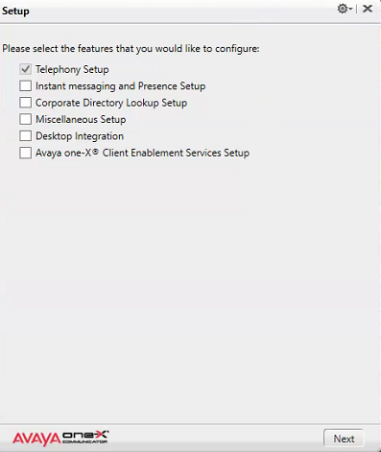
- You should see a window like this… It may already have the extension and password populated if you have set this up before. That’s fine if it does, just continue to go through the steps to verify all is configured correctly.
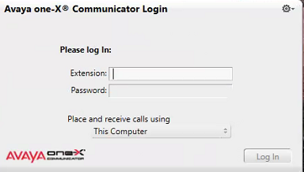

- To configure the Avaya OneX Communicator click on the sprocket icon top right of the window and choose “Settings”
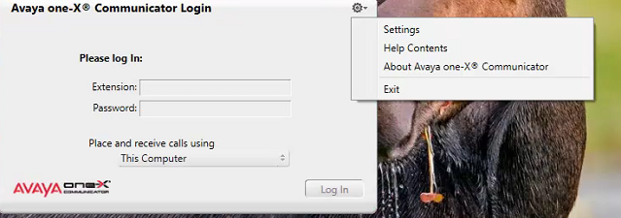

- Your default view will be the Telephony Settings page. Fill in the settings as shown below, first with changing from SIP to H.323 then fill in the extension and password. If you have yet to receive or have lost your extension and password please email itsupport@georgiapoisoncenter.org or call 404-856-6250. Once you have done everything above, Click OK and the software client will ask you to restart. Click OK to agree to restart.
Note: If the Extension provided to you is listed as 5-9131 you will enter in the extension and password fields as just 59131 without the dash.
- After the client restarts, go back into the settings as shown in step 4 and click on the Add button on the server list and type the IP of the server which is 10.7.22.100 and click OK to save the server.
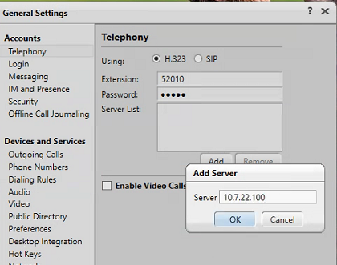

- Make sure “Enable Video call” is deselected (Everything should look like below) and click OK to exit the settings screen.

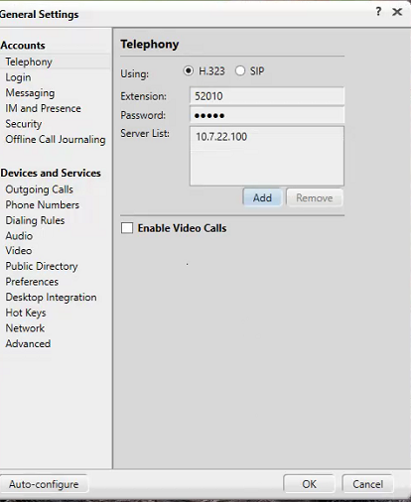

- Make sure “This Computer” is selected for making the call as seen below and click on “Log In”
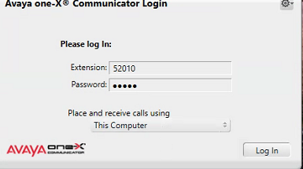

- Once logged in it will look like this
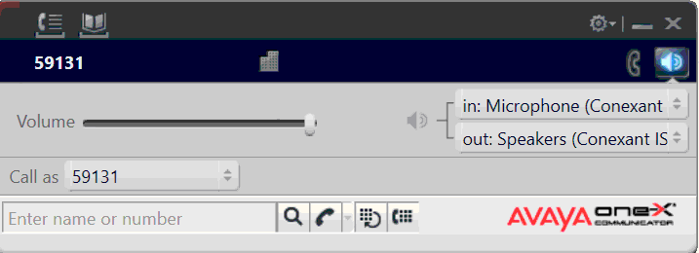

- Click the top left icon that looks like a phone to “Show call log” and then the “Show Dialpad” button which is the 4th button of the set of 4 buttons. The buttons are lit in blue and should look like below
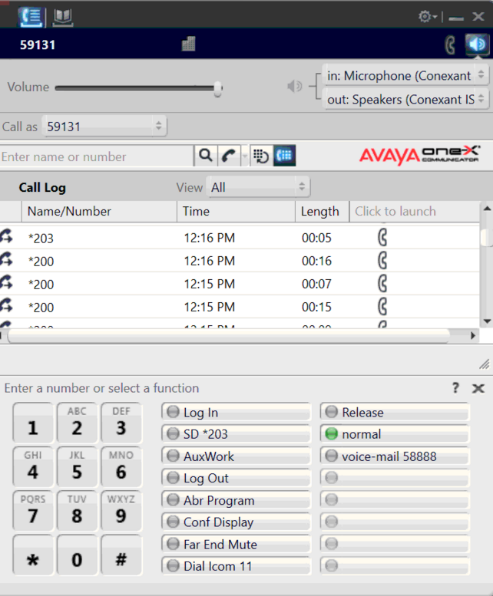

- Next step is to login as agent. This is done by clicking on the “Log In” function next to the Dialpad and putting in your Agent ID and Password. The password is the same as the Agent ID which should have already been provided. If you have not yet received or lost your agent ID and password please email itsupport@georgiapoisoncenter.org or call 404-856-6250
Note: You must put the ID and password in fast or the phone will make an alarm sound. Simply hang-up by clicking the red phone icon and click the “Log in” function key again next to the dialpad.
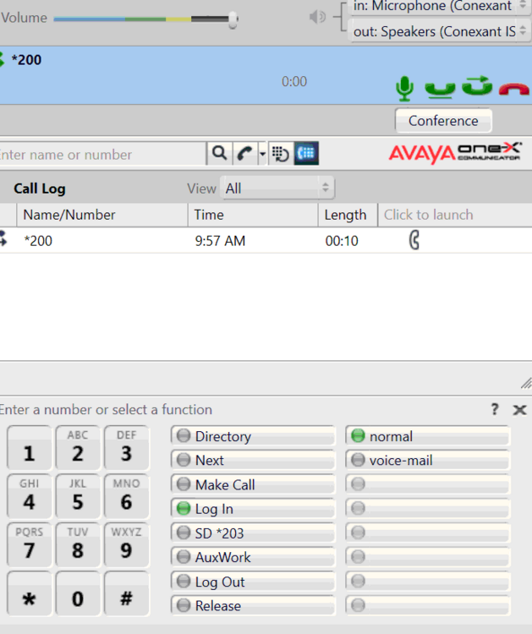

- Once logged in as agent you will be placed in AuxWork which is the same as being in released mode. You will NOT receive any calls while being in this mode. If you are ready to be available then you will need to click on the SD*203 function key where you will now be able to accept calls from the Queue. You will notice the Auxwork light is gone however the SD*203 is not but that is normal. Just click the Auxwork function key again if you need to release. For any further questions please contact the Georgia Poison Center helpdesk.
