August Staff Meeting 9/6
Tuesday, September 6, 2022
1:01 PM T. Witcher

-Dr. Lopez - Introduction of special guests: Active Shooter Training module.
Grady Presentation: 3 guests to present Justin, Mark, and Chris.
Justin - Law enforcement. Gives background of what this awareness will provide to each individual whether in office or at home.
Mark - Retired Fire fighter paramedic.
Running and Hiding effects and how to remain safe during active shooter lock down training
This module is brought to us by: Southeastern Tactical Enterprise, Professional public safety.
RUN HIDE FIGHT:
Most of these incidents occur in the workplace and consists of mostly retaliation.
Pay attention to Suspicious packages and remember to report it immediately.
Code Silver - Active Threat Internal or external issue at the hospital.
Dial Ext. 55555 or 404-616-5555 - Grady Public Safety. (for suspicious activity)
Remember to email lwood@gmh.edu - Feel free to reach out to this person if you have any advice on protecting our hospital.
- Remember RUN > HIDE > FIGHT
No alarm on the kits. But the kits provide things that are needed to protect you and others with an injury.
Recording began at 2:
-Britni Overall - EDU updates:
Jay and Nicky on outreach education! Starting a TIKTOK account.
Finalized a sign for training site.
Bezoar updates let Britni know if you need to update your Bezoar profile.
2 upcoming Health fairs in October.
Education Session:
-GPL chimes in with non-emergency topics
- Announcement about survey monkey 70% selected Ga Aquarium for the Annual end of the year Staff Meeting.
Funding we will be approached to CNP to assist with funding.
GPL mentions 3 years of no annual staff meeting. This should give us more lever edge to receive more funding this year for Staff event.
And he will be working with Tiaona moving forward to secure the venue at the aquarium for December 13,14, or 15th.

Stroke updates Jason Tully:
2:48pm Please see video for these updates on numbers.
-Gaining speed with stroke Volume 4.03 calls per day
-40 calls ahead per month.
-Jamarius, Ellis and Charisse are taking close to 15 calls a day. Robert night shift completing 39 calls per day.
Please see video for updates on YTD stats.
42% handled by SPIs.
40% after hours
20% weekends
Remember HIPPA and do not send to public health. (Rem. to removed DPH)
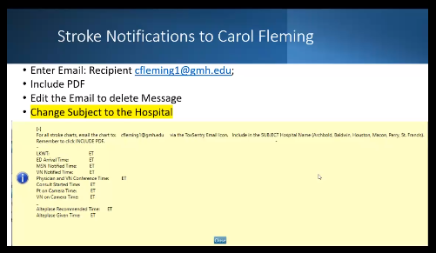

Blue Sky shift change. See video for updates.

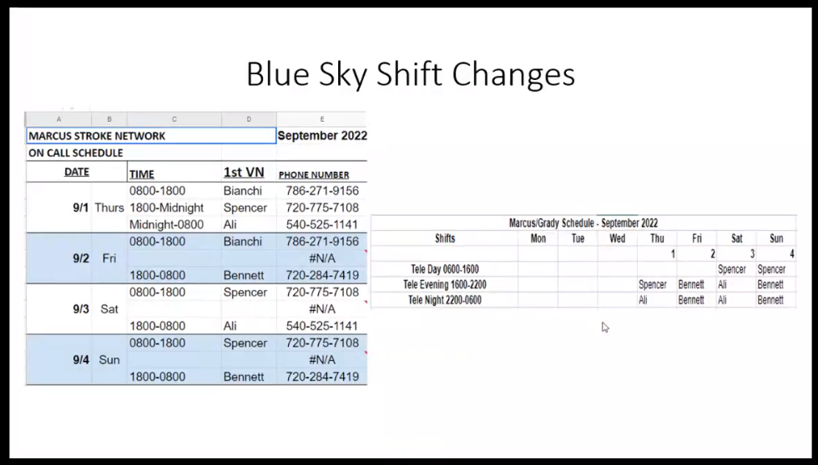
Schedules: Please notify JT or SH if JT is not available. If you are able to, please enter it in to When to Work as well.

GPL IT Updates and Issues:
Airespring outages: Moving calls to Avaya system. Updates are still being rectified. Please remember to log out at the end of your shift both Mitel and Avaya phones.
Dr. Lopez reminds us that this will need to be a mandatory habit.
Instructions are shown in Bezoar: Avaya Review and Tutorials HARD PHONE
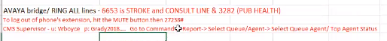

- Mute 27238# Scroll down and select Log out.
GPL:
- Remember DO NOT call IT on Cells Please dial 6250 ext. ONLY!
-When the IT staff is on-call please protect their time being accounted for by calling 6250 ext.
-If IT says call back in 10 mins call 6250 ext. only.
-This number can be found in BEZOAR as well. (404-856-6250) if 6250 ext. is not accessible to you.
Once a month IT updates one week before staff meeting. This will help minimize down time. More details will be given in our next staff meeting.
- Creating tickets: SPIs aren't generating tickets. Going forward. We will integrate a Teams ticketing service within Teams.
Please see video for a small presentation on how to submit a ticket through Teams.
- Remember to: @ITSUPPORT, give a title and explain the problem.
-This will go in affect in September.
GPL:
- Covering Clayton office and Badging updates please reach out to Tiaona on coordinating a time to set up with Shar’da on getting access and badging. Call or email her for any assistance needed while there.
- Exit doors: we are currently having issues with the exit doors. JLL will be replacing both doors. If access needs to be added to your badge, please let Tiaona know asap.
- Snake drill coming soon. Dr. Geller will be planning a Drill with Zoo Atlanta to have a drill for a Zoo worker getting bitten by a venomous snake. We will have a stimulated scenario will go in effect soon.
- Chief Policy officer canceled: we will be doing more begging for allegation funds.
- Grady currently in crisis mood for closing of WellStar. Cancellation with one up due to crisis at the moment in the Metro area. AMC at the moment will not be taking over Grady or vs.
-WellStar no longer working with AMC. Grady has not mentioned anything at this time
Patrick Filkins:
Grant updates: involving Dr. Kinan and Dr. Filkins - Began 9/1/2022 Federal HRSA Grant, Telemedicine to OUD Hospitals for Rural hospitals for Telehealth. State Funded for Non-profit.
Still in planning phase. We will hear more about updates in a future staff meeting.
5 hospitals signed on at this time. PF mentions that we are still in planning phase.
Hospitals will phone us something similar to Stroke calls.
More updates will be discussed in our next meeting.

Holiday Scheduling:
PF and SH: GPC policy states you must work 2/3 Holidays and we need to get this schedule completed. Please remember there are 6 total holidays accounted for. You must work 2-3 out of the 6. Staff must sign and be scheduled for 2/3 holidays per year.

Marketing adjustments Ashley G. was not able to attend our meeting today. However, HR will respond soon GPL will keep us posted. GPL had One on One meeting and she did mention she still supports the initiative.
Stephanie Hon: NACCT next week. Office will be empty 9/13 – 9/18
Please remember to get Booster if you have not already.
Local clinic, pharmacies and vaccination sites are provided on Grady website and CDC may have information on scheduling those appointments.

SH: Grady Annual Mandatory Training
PRN or Fulltime employee: SH sent out an email for curriculum module. Module should only take a few minutes.

Biometrics: screening begins again Sept. 13th waiting for more information to sign up for an apt.
If you have Grady insurance and you pay for yourself and or family, it is very important to get this done to save money!
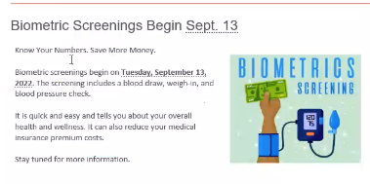
Click the link for more info on Biometrics:

https://gradymemorial.sharepoint.com/news/Pages/Biometric-Screening---Sign-Up-Now.aspx

Biometric Screening - Sign Up Now
9/7/2022
​Biometric screenings begin Tuesday, September 13, 2022. The screening includes a blood draw, weigh-in, and blood pressure check.
To schedule your biometric appointment, click FAMILY MEDICINE. You can also login to MyChart to schedule.
It is quick and easy and tells you about your overall health and wellness. It can also reduce your medical insurance premium costs.

Get knowledge on your health and save more money now!

Telstrats: records you at the agent level and not at the trunk level. If a call is transferred to you it will even record a transfer.

Quick Active Shooter refresher:
