Staff Meeting
Tuesday, June 27, 2023
1:32 PM

1:33pm
GPL Opens to saying hello and Goodbye to the Fellows.
Addressing Mid Fellows later.
Goodbye to PharmD Fellows: Nicole McElroy - Miami Children’s Hospital, and James (Jay) Adams Clinical Pharmacist Thomasville Ga.
Dr. Zach Illc Accepted with FDA in Baltimore MD! and Dr. Teitelbaum will be signing on with CDC, Dr. Hallett will be staying with our Medical Tox Faculty.

1:45pm Guest Speaker: Skyler Brennan and Dr. Julie Gabel: Public Health IPH (Rabies Scenarios and Q&A)
-For full presentation please view video.
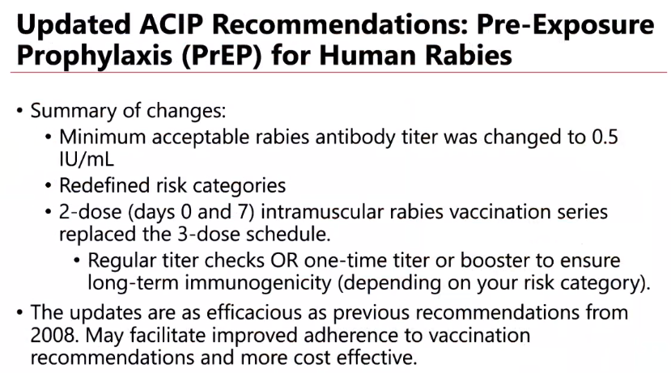

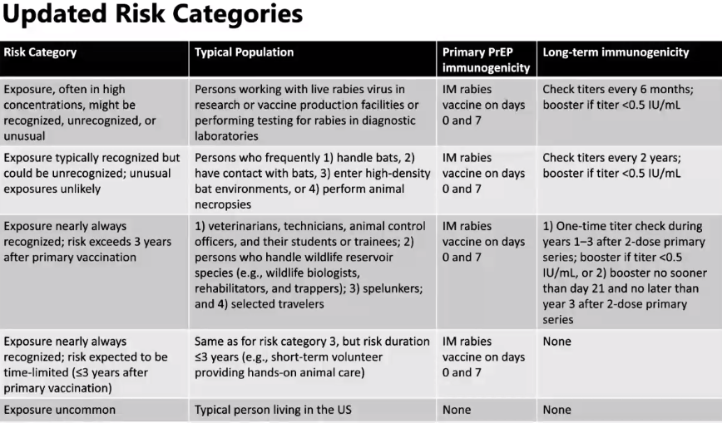
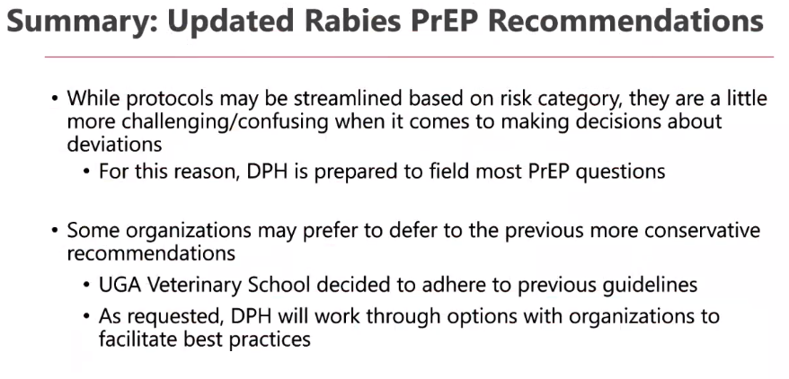

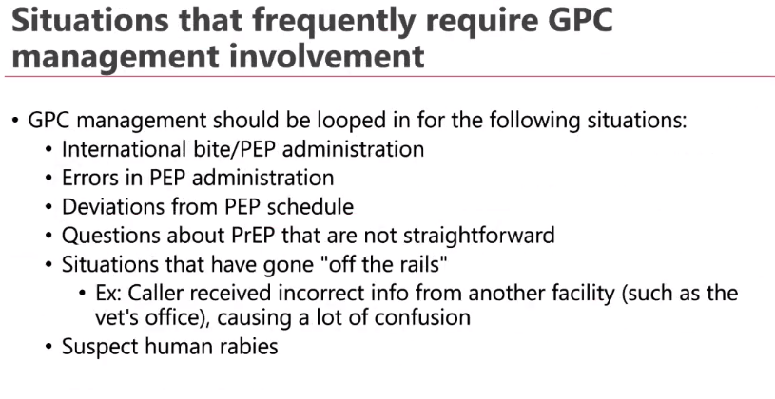
To answer all the questions:

3:15pm. EDU Updates: Britni Overall
Health Fairs have been going great. If you are able to help out with the health fair Please reach out to Britni and let her know.

3:17pm:
IT Updates: With Wilson and Ty.
-Teams - Bandwidth, in discussion regarding troubleshooting slowness. Airesprings: set up Bandwidth Rule - this will assist with speed up and help things run more smoothly.
Handling older PC's. About 8 total that are outdated, a list will be sent out. We will be replacing hard drives to keep the PCs from crashing.
PC's monitoring: please let IT know if you notice a difference in your machine that may be delayed or below normal performance.
If your machine has to be totally replaced, we may need to then replace monitors as well.
-Tel Strat: Mitel tag team, new software in the works being tested at the moment. SPI's and Stroke agents still cannot see recordings. Ty will look into this.
-Bi-weekly 4:30am reboot will still take place until we complete collecting data.
-Know before training: Fishing campaigns that IT runs to secure the workplace and person information.
If you spot anything suspicious: please report as a fishing attempt.

3:27pm Dr. Geller MD Updates
Updates on Budgets; working to keep spending down.
Christy Hallett will join us as faculty next week.
New transitions will proceed in the next 18 months. Dr. Brent Morgan will transition duties with Dr. Geller.

3:30pm Dr. Lopez takes over staff meeting:
Budget updates: Grady Admin, Supporting Doctors, additional funding, efforts have not been successful. Measure will be taken into our own hands to start rolling out with a number of changes. 2-3 step process to begin certain budget cuts.
Personnel issues will take place within the next few months.
Scheduling issues will probably take place from administration and SPIs etc.
We are looking to cut from all aspects. We have done all possible to help our budget situation. We have currently ran into some legislating obstacles that we did not expect. More updates will be provided in our next staff meeting.

3:38 pm SH Operations issues.
Abstracts:
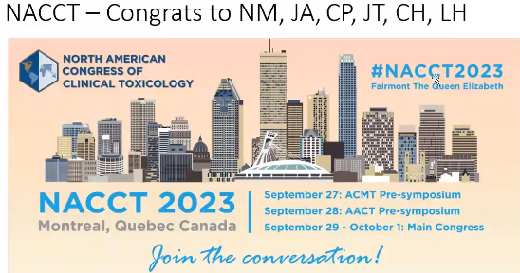

Lloyd will be celebrating 50 years as well and will be attending, Britni will be attending. Dr. Lopez mention how proud we are of our group!
AACT President still deciding between Atlanta and 2 other places. If in Atlanta we will be given the opportunity to praise our Poison Center.
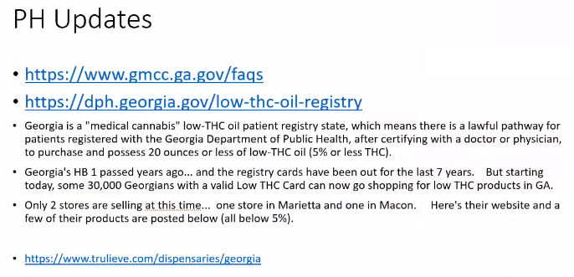
Monteal - Has been receiving the highest number of cases in poison dex. To help with data management Crystal will be the go to person for any questions. Dr. Hon will send out an email with more information about Monteal
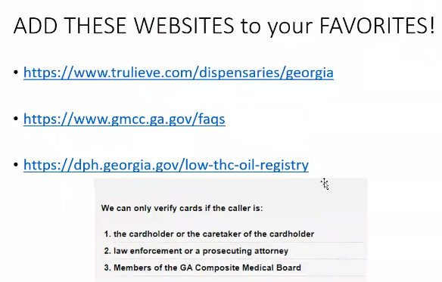
After hours schedule for DPH
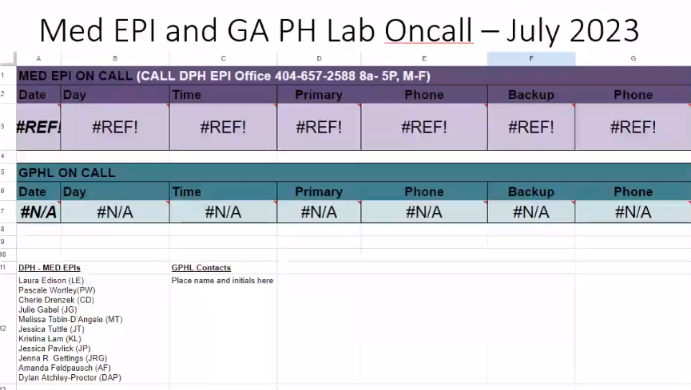

GA PH Lab: Ga Public health laboratory.
This will also be updated and sent out by Dr. Hon.
SCHEDULE WILL BE POSTED IN BEZOAR. Please refer to video for more details for the on-call schedule.

Meeting Adjourned

