Staff Meeting
Tuesday, July 25, 2023
1:34 PM

1:34pm GLP, SH
Before Dr. Lopez introduces the new Fellows of GPC, he breaks down the funding provided that supports the Fellows funding.
Intro to new our new Fellows:
Fellows: Mayank Gupta, Joseph, Matthew
Amber Patt PGY 2 and Andrew Yetka PGY 1

2:09pm RG, Medical Director Updates:
Status on budget blows, 06/30 lost 340k final revenue given. Est. Losing 7/8k lost.
He explains the impact where we have been hit most.
Federal Gov. Matched certain grants provided during COVID. State denied funding for upcoming years.
Federal Gov. also took back bonus for covid match rate causing us to lose 500 thousand total.
Match rate is now back to where it was 7 years ago: while the cost of living has gone up.
We did have other contributors, but that funding has gone towards salary increases. Dr. Geller mentions, we are trying very hard to keep the program running. Financial experts are very confident that we will soon get funding to cover up coming years. Confirmation should be provided in the next staff meeting.
-Sal questions how likely another cut will be made.
Changes during Dr. Geller's transition will begin Aug 2023 with Christy H. taking on more responsibilities.
SH:

2:25pm Britni Overall: Education updates
Pharmacy Credits are now provided.
Sending out newsletter for back to school for participants in our courses.
Tok-tok Florax challenge with Channel 11 News look fwd. to this soon.

2:27pm IT Updates begin with RG, GPL, Wilson and Ty from CNP
Wilson: Older PC updates: past refreshing older PC's, better monitoring of the equipment in office and Teleworking equipment as well.
We always want to make sure machines and all IT equipment's are running properly.
-Email's will be sent out to those with dated hardware and old equipment that needs to be replaced.
-TY: Telestrat recording system: time frame has now been extended to a longer time frame. Allowing shifts t to go back to regular scheduled times.
-Toxsenty we are moving over to 2443. Patience will be needed during this time while installation is taking place. If you are still having difficulties, please properly shut down your PC and allow it to reboot.
To view your performance: CTRL ALT DELETE - utilization
-Remote work policy Updates: Dr. Lopez leads, important things to come as we rethink things that we experience. We all will have a hand in prepping for new policy
Better standardize new issues and maximizing systems that will allow us to be efficient with less lag times. Centered around our internet settings. ISP and the plan you have subscribed to. Proof will be needed for provider and the plan you have. IT will need to call these providers. To verify the plans and speeds provided to residential customers.
Things that will and will not be allowed soon and we want all to be prepared to continue to work remote. Guidelines we will strictly adhere to. Reinnervate things we highly encourage all to make sure your internet access meets all policy required going forward. If equipment is not properly functioning, you will need to be prepared to return to the office immediately. ISP charging small fees to use these devices such as the mariachi.
Third party equipment and support: when you decide to work without ISP you will be responsible to make sure your PC is running properly. For examples for certain connections/providers place see video. 1:17:00
Policy and procedures will be being and will have them completed before our next staff meeting.
Dr. Geller A minimum platform will be required going forward so that GPC can meet the speeds that are needed.

2:58pm Employee of the Quarter 2.
GPL and SH - quality communicator was the theme.
Who takes communication seriously on and off shifts? Tries to improve the quality of our service. New Coding Queen goes to Christina Hash! Voted the employee of the Quarter 2! Way to go!
GPL configuring office space for Christy Hallet.

3:05pm, PF Real time, schedule updates:
New schedule block - 9/23. Please get all PTO requests in ASAP; schedule change Diaonna will be coming off of nights.
-Real time grant work project. Finally at the one yard line. Changes have now been approved. Planning to go live soon. Code tanner and substance abuse on the info chart and select real time. PF will send email when we official go live.
15min time shift change. We do not go down to 3 with EOS. Please speak with PF for any questions regarding your shift. Jason mentions we are still evaluating each shift and what works best.

3:11pm SH Operations Agenda:
EQQ 2nd Qtr./Staff Acknowledgements: 2023, 2023, EQQ 2nd Qtr. - Quality Communicator Christy Hash, Sal it's been a year! Congrats to you being with GPC! Shannon - 14 years, and George - 9 years.
August Pharmacy Student Welcome
Andrew Bi, John Butgereit, Chanecia Jackson, Jordan Spurling
Students will be mentored by our poison center staff. This year we only have Amber. So, students will need mentoring for all poison center specialist.
CASE REMINDER: For more details, please refer to video 1:47:42
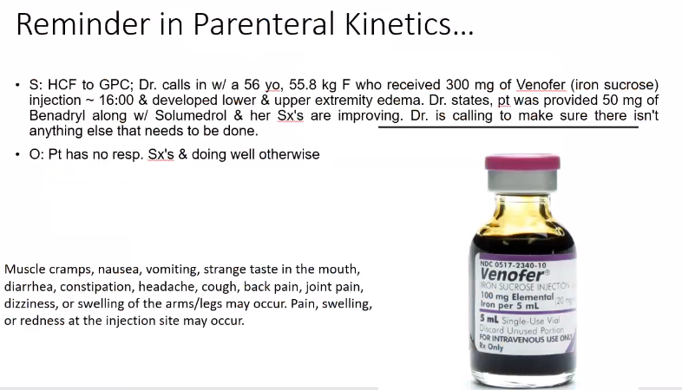

GRADY NEWS: Mandatory Course
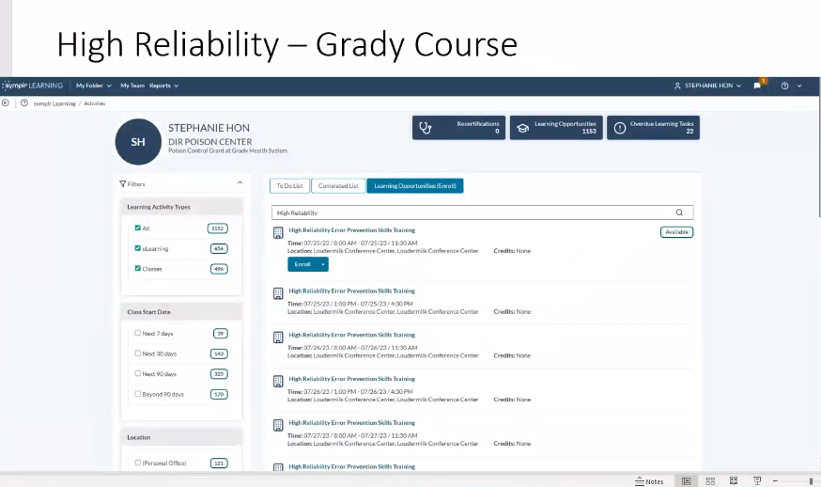

SF Continues on to Public Health Updates: 2:14:23
Big thanks to Crystal on working with Poisondex. If you receive any calls: Please code the product Specifically!
This may help with getting funded for his step alone like other poison centers.
PH Outbreak: SendSS was down last weekend… New legislation, 1. HIV and syphilis testing is required to be performed at the first prenatal visit, 28-32 weeks gestatio, and upon delivery regardless of previous negative test results. 2. Tests for syphilis and HIV must be performed at delivery at delivery even if confirmatory results won't be available prior to hospital discharge.
-AMOEBA NAEGLERIA FOWLERI death in GA - Warm, Hot water, spring lakes and rivers.
Symptoms can be mild at first, but they worsen quickly. Symptoms usually start about 5 days after infection (range 1-9 days) and can include headache, fever, nausea or vomiting. Later symptoms can include stiff neck, confusion, lack of attention to people and surroundings, loss of balance , seizures, and hallucinations

CELL PHONE Updates have posted to Bezoar.
PLEASE REMEMBER WHO TO CALL…
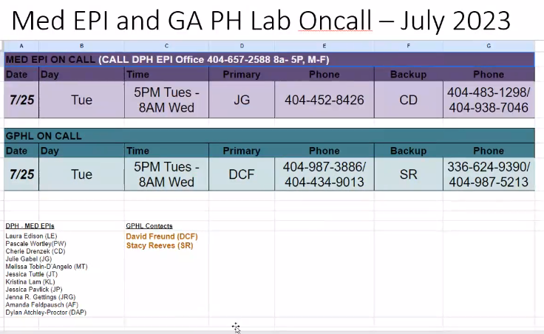

SH: Observations for Opioids… Providing patient no more than 80 to 90 morphine equivalent per day of bad opioid about 90 Mil equivalents per day.

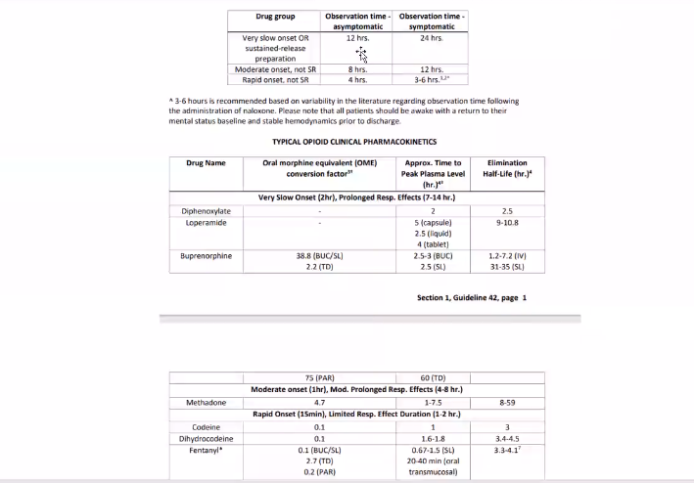

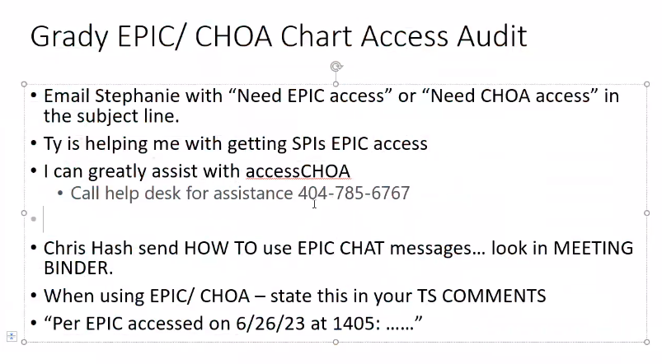
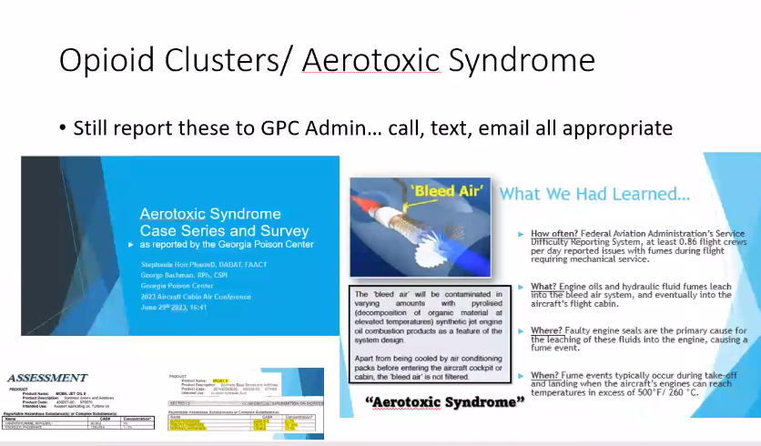

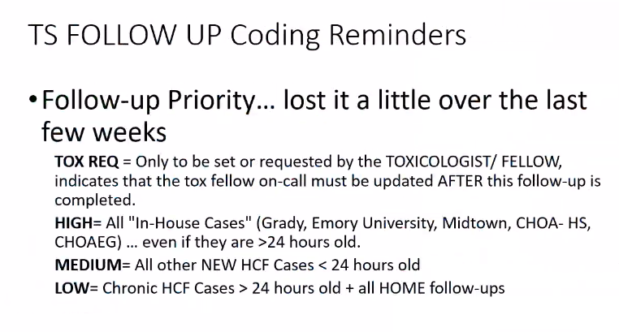

Stroke updates: Please see video 2:46:45
