Staff meeting 9/19 1:30pm not recorded
Tuesday, September 19, 2023
1:36 PM

Intro: GPL, SH
FMLA, Resignations, Terminations: GB, LH - Retirement Farewell. You will be missed. We appreciate your years and dedication of service.

SH will create a zoom live stream to celebrate. LH doing NACCT conf.
Welcome Inter. Tox Fellows from Oman: NAMES ENTER HERE
Congrats to PF and Karlie on tying the knot this coming weekend!!!!
Reminder: PF needs a few days away from the sched. Please call SH for the next 2 weeks.

MD Update Dr. Geller: 1:51pm
Continues with GPL on operational transitions parting ways with a few people due to budget cuts. We still do not have any updates at this time. We did receive a onetime contribution to help us meet our needs. IRA savings: Hack of multiple funds it’s a comprehensive disclosure. Careful scrutiny so please inquire and ask hard questions make sure your identity and online accounts are secure. You are encouraged to speak with Ty M. in IT for more information.

GPL gives updates on Operation: DPH sent out updates for the following:
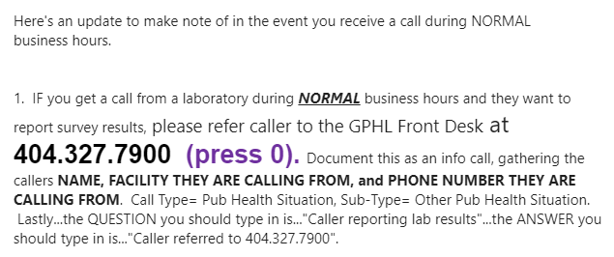

2pm SH: NACCT travel updates next week 9/27 - 10/1.
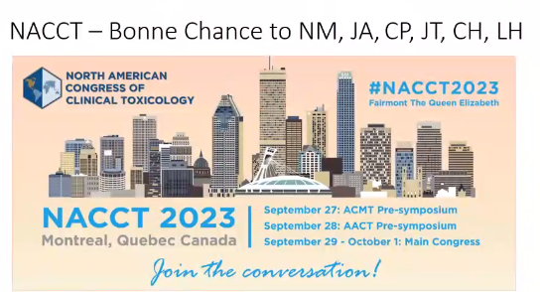

-Acknowledgments to: Dionna 10 YEARS! Sandra - 20 YEARS! WOW, Amazing. Thank you both for all you do! Thank you for being a part of our service.

-Grady Health BIOMETRICS SCREENING: Email will be sent out. Please also check your Grady email. This open enrollment must be complete once a year to help with health benefits financially. An appointment must be made. This is only done on Grady's Campus. You will be discounted 75 dollars per paycheck. Starting this week Monday September 18th until Dec 2023. for you benefits of the year 2024. This is optional but the discount is worth. To schedule through MyChart a link will be sent out soon by Dr. Hon. Advertisement went out for Covid booster They do not have one at this time this is not mandatory.
-Week of NACCT we do have OT available: Please contact Dr. Hon immediately to sign up for OT.
-High Reliability is still mandatory and needs to be scheduled. Out of towners you will still need to travel in to the office to partake in this session. Class are available until the end of the year.

-Flu Vaccine is no longer optional. Proof will be needed. Please scan or screenshot your proof of shot to Dr. Hon.
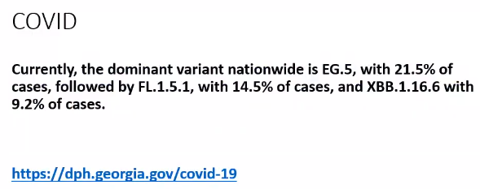
-The DPH website has not changed much but SH did challenge them on the updates.
Weekly statistics. Still offers testing options. Vaccination information is still provided. Still must stay home for at least 5 days and be covid negative before returning to work or school. Mask is still required for day 6-8. Some counties still have funds to do contract tracing refer these calls to home/county health department.
-We have received COVID funds. Continuing with the Public Health Hotline. It will be a separate que on the dashboard. We have assigned individuals for the specific calls. Nicholas has been retained for these calls. Beginning today we will do more of a bridge version of stroke.

GPL introduces VP emergency services Ashley Gresham: 2:30pm
-Financing and conv. With fin. Partners. Budget/Funding updates: Gov. and budgets talk will take place at the end of this year to support the months of Feb - April in hopes of increase in funding to support GPC.
-Cuts and changes are not easy but are supported with no ill intent. Marcus Stroke program funding has been suspended. Future opportunities may come. Grady will continue to support the funding to keep this funding running.

SH continues - 2:36pm
-Revised CAP LX Survey
Remember during and after hours you may need to direct the call to one of the following.
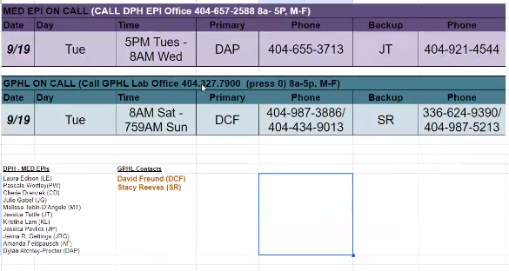

Rabies update: Please see video for more in-depth breakdown or refer to Bezoar. 1:10:00
Good news - in the next few weeks we will receive a new rabies state guideline on hoe they will be conducted in Georgia.
Will make the new policy as well. 2016 compendium amendment animal rabies control this can be found on Bezoar. All unvaccinated animals it is stated that all Dogs and cats (animals) that have potential high exposure must partake in a controlled facility observation for weeks. That animal that may come in contact that has not received a vaccine should be vaccinated for rabies right away and observe by owner for 10 days in isolation. Pet racoon or pet skunk Fox etc. are still considered a wild animal. This means there is not 10-day observation. There is no recommendation.

-Hospital name change: Bezoar, scroll through to recent updates for hospital name change link. We have provided a chart that allows you to see all updates on the forever changing landscapes on all hospitals in the state of Georgia, clinics, numbers, addresses etc. can all be found here. This document is in real time and everyone has editing rights to update this list as needed.
Here is a template to follow while utilizing the spreadsheet.
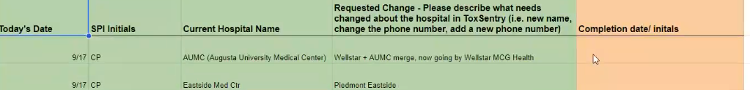
SH will then update this information in to ToxSentry as you add it to this list.

-Consults with Tox On call Reminders: Consults with tox on call please remember to code your fellow on call. Video 1:22:43
This is a form of active QA. This helps with monitoring the calls on the fellows. Rem. To code the fellows to help this process. When providing consult. Remember to collect all data. This includes labs, vitals, EKG, asper levels, recommendations etc. If you noticed something is off or you are unsure of the connection of the exposure do not forget to address it again.

Brief announcement/off topic: 1:32:45 go back and review. Wellbutrin dosage. 600 mgs total is where concerns should begin. ER observational visit should be suggested. Better outcomes are needed. A follow up is needed within 8-24 hrs. of the outcome. Weight is needed as well.

-SPI-CE '23 has posted. Can be found in Bezoar. Log in is needed.
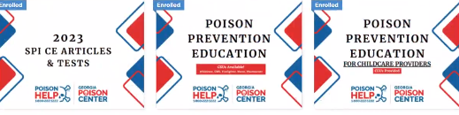
Radiation Training Course
-RTN: radiation treatment network. Acute radiation syndrome. Poison info special knowledge is important. Exposure; if it happens it's going to happen quickly and spread tremendously. We should all be more aware going forward. Training exercise can be done online and at home. Funding has been involved as a partnering poison center. We will conduct a drill with our partnering poison centers. More information will come in due time.
QA partner emails will be sent out soon.
October Pharmacy Students - 3 new students joining the phones week 10/3 to continue student rotation.

3:18pm GPL
-TW policy updates/Agreement reminders: please remember to complete and turn in all documents to continue to TW - It is no past due.

-IT updates: Issues that need to be followed up on - Remember to create a ticket.
-Anti-virus updates will go on in the background. If install or updates are not working, please let IT know. Security prevention will be put in place as well.

EDU updates: BO Out of the office 3:30pm 1:54:00
Health Fairs coming up Helpers are needed. Please reach out to Britni if you plan to assist.

Stroke Updates: TJ Please refer to Video for all updates in detail. 1:55:30
Program has come to an end. This is a difficult time that we have had to transition into as cutbacks take place and to see what's to come.
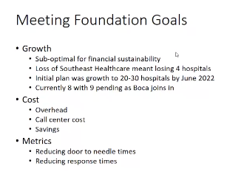
We unfortunately cannot afford the Stroke call center to continue the grant.
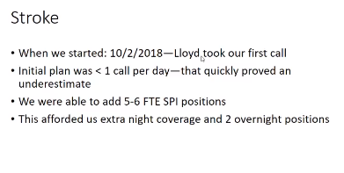

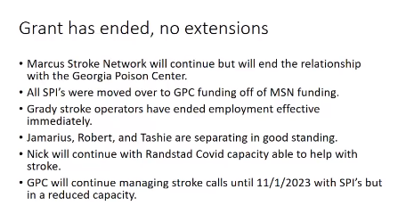

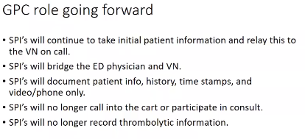

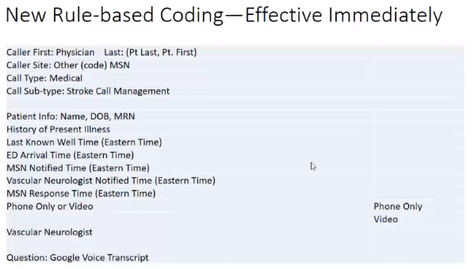

We need to all log back in to be added back to the board by 4:35pm
Meeting adjourned. 4:29pm

