PROTOCOL FOR CHEMPACK RELEASE

Call comes into the Poison Center- This number will be for paramedic, hospitals, etc.

Numbers to call to request CHEMPACK:
Georgia Poison Center – 404-230-8990 (this number by-passes the queue)
Georgia Poison Center 1-800-282-5846

Caller’s Request:
- If caller states, “I need a CHEMPACK.”, ask: “Why do you think you need a CHEMPACK?”
- If caller states, “I have many patients with symptoms of or exposure to an organophosphate”, ask: “Do you need help getting more medications to treat them immediately?”

Questions to ask the caller:
- Have you used (or will you have used) all of these resources within your hospital?
- Number of patients involved (estimate)
- Patient presentation
- Location of patient and exposure
- Information about the caller (name, call back number, and info)
- Where do you want the CHEMPACK materials to be delivered – specifically?
- Please inform the caller that we will start working on their request right away, but it may take several minutes to reach an appropriate person at the nearest CHEMPACK site. Offer them the choice to hold and be conferenced in from the beginning, or to have us call them back after the CHEMPACK site contact has been located.

Linking the caller to the CHEMPACK site contact:
Once the call has been made to the Georgia Poison Center and information has been collected, the poison specialist will locate the closest CHEMPACK and the poison center or the site where the CHEMPACK is stored can make the decision to release the CHEMPACK. The CHEMPACK site point of contact should be identified from either the GOOGLE CHEMPACK MAP or the Address Book CHEMPACK directory, not from the hospital Address Book.
- The poison specialist will link the caller, if they have chosen to remain on the line, to the CHEMPACK contact of the site with the necessary CHEMPACK assets available that is the closest / fastest route from the requesting caller. (What we are looking at is shortest transport time, not necessarily the closest supply location). Delivery can be requested to a hospital, to a field location, or both.
- If the caller chooses not to hold on, the poison specialist will return the call once the hospital contact has been reached.
- The poison specialist will remain on the line with the caller and the hospital contact, to then document their interaction and plan of action in a ToxSentry EXPOSURE CHART.
- Immediately call Medical Director and Operations Director, or their designees if either is unavailable.
Linking the caller to a Toxicologist:
Poison Center receives the call, if they ask for something reasonable we are going to say “yes” (All calls will be recorded). If the request does not seem reasonable, the poison specialist should inform the caller that they will put them in touch with a toxicologist promptly.
- If the Medical Director has not yet responded, emergently contact the first on-call Toxicologist.
- The poison specialist will then link the caller with the Toxicologist.
- If the caller chooses not to hold on, the poison specialist will return the call.

If the requester persists in their request against the advice of the medical toxicologist or refuses to consult with the medical toxicologist, the requester should be advised that they will be responsible for the replacement cost of the assets once these assets are released, if the facts subsequently demonstrate that the assets were not indicated in the management of this exposure.

Proceed to release assets as below. The DPH Office of Emergency Preparedness and Response (EPR) houses a 24/7 on-call team consisting of primary and back-up duty officers at this phone number and has been included in our updated CHEMPACK plans. Please call DPH Duty Officer Line 855-377-4374 to update when a CHEMPACK has been requested. The Medical Director or the Operations Manager or designee will also immediately contact Tracy Dabbs, the pharmacist for Emergency Preparedness and Respond for Georgia DPH at 470-409-3370.

How much to deliver?
We want to send enough to supply at least 2 doses per patient expected. Do NOT deliver a partial case (except as below); if 2 doses per patient results in a partial case, move the entire case.

The only exception regards pralidoxime. Where a partial box is needed, consider splitting the case of pralidoxime and transferring part of the case if the next nearest unused CHEMPACK site is distant and the nearest Hospital container with pralidoxime available is also distant.

Additional considerations:
If an entire case is released and the releasing site is at substantial likelihood of also receiving exposed patients, consider also moving the necessary assets from the nearest Hospital container to the involved hospital site(s), even before a request is made by the hospital that has released its CHEMPACK assets.

Who is responsible for delivering the CHEMPACK to the site?
- The site that has a CHEMPACK is responsible for coordinating the delivery of the CHEMPACK to the site where it is needed. There is a default choice for most sites (such as the Sheriff or Georgia State Patrol). They should use their default method if it can be immediately put into use, or else the most expeditious method immediately available that can transport using “lights and sirens” should be used – i.e., if there is an EMS unit or law enforcement or fire unit at or close to the storage site of the CHEMPACK, try to put them into service as the delivery method. Consider also the use of air transport (either law enforcement helicopter or medical helicopter) if more expeditious and locally available, especially where transport distances are long.
- Restocking of CHEMPACK sites is the responsibility of ASPR/SNS, as CHEMPACK Program is a federal program maintained by this agency.
- Do not break open a “new” CHEMPACK if some is left in a recently opened CHEMPACK at approximately the same time away from the second site of need.
- If delivering to a hospital, the person signing for their receipt should be a physician or pharmacist. If delivering to a non-hospital site, the person signing for their receipt should be a physician, pharmacist, or any other individual in a leadership role at the scene (such as, but not limited to, the Incident Commander or the Site Medical Officer).

Keeping and Tracking the Database:
- CHEMPACK Point of Contact (POC) database will be created and maintained by the GPC. As of January 2011, this is a database within the Address Book program. As of August 2017, a second database is also located within the Google Maps program.
- The database will contain hospital pharmacy numbers and up to 3 contact numbers for each of 3 CHEMPACK contact individuals (work, home, and cell, and which number to try first according to the time of day).
- GPC management is responsible for maintaining database, and receiving updates from the state representatives.

Rev 10-30-17 RJG/ SH
3-2-25

CHEMPACK CONTENTS
As of March 2026, there are 43 EMS Containers deployed throughout Georgia. There are only 3 Hospital Containers statewide; these are located at Hamilton Medical Center, Children’s Healthcare of Atlanta at Arthur M. Blank, and St. Joseph’s Medical Center in Savannah.

CHEMPACK Container Formulary
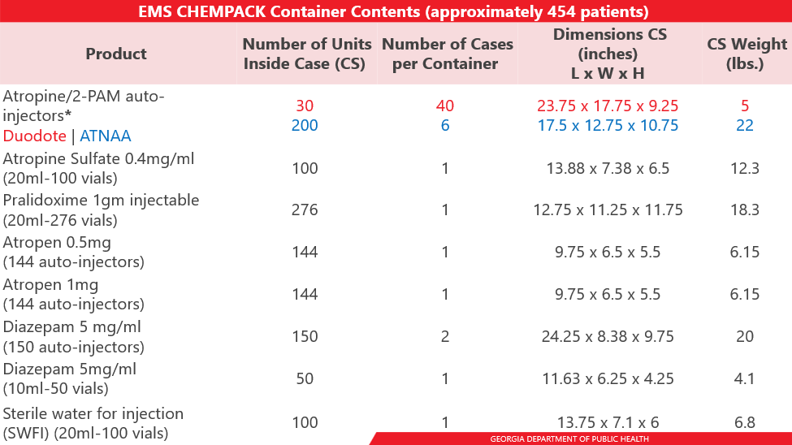

**ATNAA (Antidote Treatment Nerve Agent Auto-Injector ((1) Atropine 2.1mg/0.7ml injection & (1) Pralidoxime Chloride 600mg/2ml injection))

